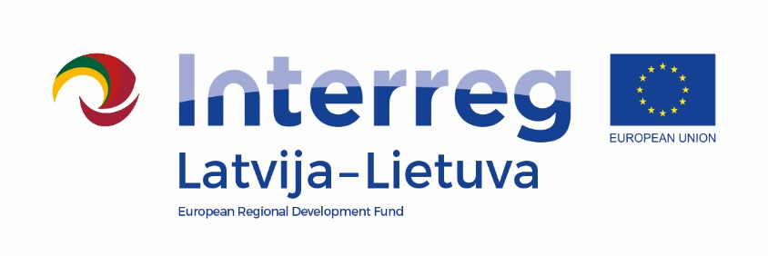

Interreg V-A Latvijos – Lietuvos Programa 2014 -2020

Project

“CRAFTSMANSHIP AS TOURISM PRODUCTS WITHOUT BORDERS”

/ Tour de Craft, LLI -539 /

Art fair

9 of June 2022

Anyksciai art incubator- art studio

J.Biliūno g.53, Anykščiai

AGENDA

|  |  |
| --- | --- |
| *10.00 - 11.00* | Registration of participants, welcome coffee  Exposition of project creative workshops results |
| *11.00 - 11.15* | **Welcome words**  Representative of Anykščiai district municipality  Kristine Smagare, project manager, Latgale Planning Region |
| *11.15- 12.45* | **Degustation of art**  Vilma Jankienė, Art curator, „AP galerija“ |
| *12.45 - 13.00* | Coffee break |
| *13.00 – 15.00* | **Active activities in groups**  **Creative workshops**  **Visiting studios of Anyksciai art incubator, exchange of experience** |
| *15.00 –16.00* | Lunch |
| *16.00- 17.00* | **Discussions, networking, possibilities of cooperation** |

* Photos will be taken during the event and this material will be used for project communication