 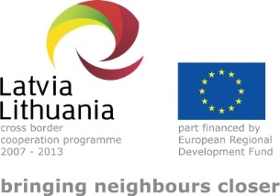 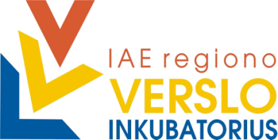 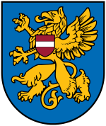

PROJECT

“Strategy for Investment Attraction to Urban Areas

in LV-LT Cross-border Region – WILLINVEST”

(No. LLV-390)

**Description of investment project for REZEKNE City Council Properties in Special Economic Zone**

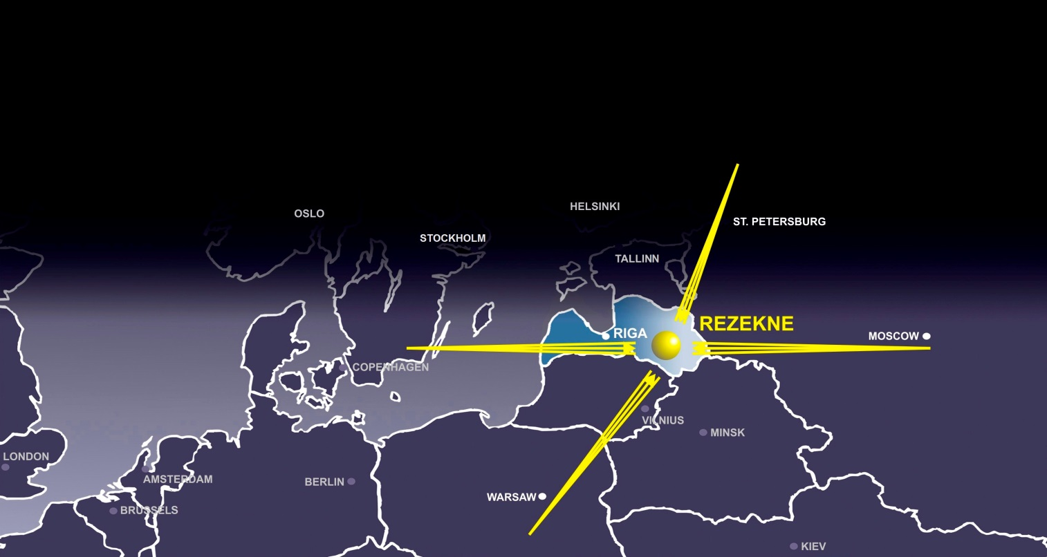

Rezekne, 2015

**TABLE OF CONTENTS**

1 LATGALE REGION in Latvia 3

Geographical location of the region 4

Transport and logistic infrastructure 5

Residents of the region 6

Education 8

Unemployment and job seekers 12

Enterprises and non-financial investments 13

Public support to the entrepreneurship 19

2 REZEKNE in the regional context of Latgale 21

3 Description of the investment project for REZEKNE industrial zone 28

3.1 Name of the urban area industrial zone 28

3.2 Location, area, zoning 28

3.3 Property rights 29

3.4 Entrepreneurship sector 29

3.5 General description and goals of the project 29

3.6 Description of the industrial zone 30

3.7 List of potential clients and cooperation partners 34

3.8 Summary of investments 34

3.9 Possible operational plan of the industrial territory in the future 39

3.10 ANNEXES – other information related to the project 41

Available technical documentation 41

Presentation of description of the industrial zone (ppt) 41

Photographs of the industrial zone 41

# LATGALE REGION in Latvia

|  |  |  |
| --- | --- | --- |
| **The CURRENT social economical indicators** | | **Indicators in Latgale** |
| Area, km2 | | 14 549 |
| Area in % of the total area of the country | | 22.5 |
| Number of residents, on 01.01.2015 | | 311 058 |
| Rate of the number of residents in % of the total number of residents of Latvia | | 14% |
| Density of residents per 1 km2 (number of people) | | 20 |
| Total GDP in 2012, thousand EUR | | 1 823 870 |
| Total GDP in 2012, ration in % | | 8.3 |
| Total GDP in 2012 (per resident, EUR) | | 6 176 |
| Number of unemployed people on 31 December 2014 | | 23981 |
| Unemployment rate, % of the total number of economically active residents | | 17.8 |
| Approximate volume of potential labour force available in the region | | ~ 20 000 people |
| Proportion of the students of the institutions of vocational education | | 45% (higher than on average in Latvia) |
| Non-financial investments (in reference prices of 2013, million EUR) | | 433.5 |
| Planned revitalization of degraded territories and readjustment thereof for entrepreneurship (ha) up to 2023 | | ~ 125 |
| Economically active statistical units of market sector[1] (in 2013) | | 18160 |
| Sectors with the highest competitiveness[2] | 1. Manufacture of other transport equipment 2. Manufacture of electric equipment 3. Manufacture of machinery and equipment | |

**FUTURE vision of Latgale for 2030**

“Smart Latgale” with 300 000 residents,

characterized by the following words – netting, cooperation and speed.

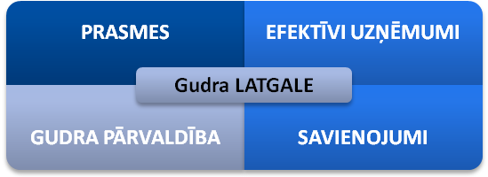

|  |  |
| --- | --- |
| **SKILLS** | **EFFICIENT ENTERPRISES** |
| **Smart LATGALE** | |
| **SMART ADMINISTRATION** | **CONNECTIONS** |

*Figure 1: Four strategic directions or long-term priorities of Latgale strategy 2030.  
Source: Latgale programme 2010 - 2017*

## Geographical location of the region

Acreage of the territory of Latgale is 14 549 km2. Location of the region is characterized by the Eastern border of the EU and the neighbouring regions of Russia, Pskov county and Belarus, Vitebsk county.

Convenient connections of the EU importance roads and railway lines connect the largest cities of Latgale – Daugavpils and Rezekne – with Riga, Pskov, Vilnius, St.Petersburg, Warszawa, Vitebsk, Moscow, as well as interconnected within the region.

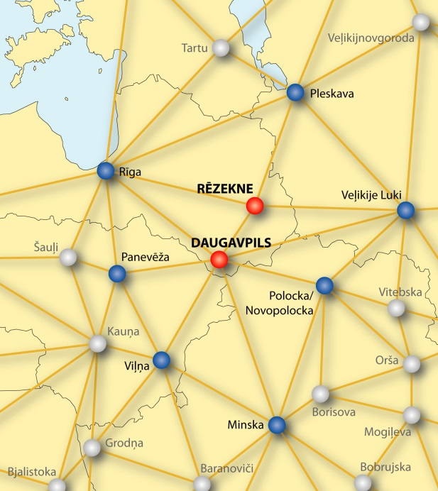*Figure 2:*

*Cities of Latgale region in the international  
network of cities (Data: LLC (SIA) “Grupa 93”)*

Latgale is located in the Eastern part of Latvia and North-Eastern part of the EU, at the same time it is the border region of the EU. Latgale region borders with the Russian Federation in the East, with the Republic of Belarus in South-East and with Lithuania in the South. Eastern border of the EU still functions as a barrier with restricted number of border crossing points and non-constructed customs control offices in the territory of Latvia, as well as strict control of freight and passenger flow. Cross-border economic links are restricted by visa regime with Belarus and Russia.

Three important international transport corridors cross the region providing for Latgale direct connections with the largest centres of the neighbouring countries – Moscow, Vitebsk, Smolensk, Kaunas, Vilnius, Warszawa, Pskov and St.Petersburg. The largest city of Latgale – Daugavpils – serves as a centre of commercial services also for the North-Eastern territory of Lithuania with approximately 150 thousand residents, around the same as in the part of the territory of Latvia.

In Latvia Latgale Planning region borders with Vidzeme Planning region in North-East and with Zemgale Planning region in the West. Latgale has been integrated in the economic network and the service network of Latvia, which is characterized by the region’s large cities’ – Daugavpils and Rezekne – links with Riga. Functional links of Rezekne – Daugavpils – Jekabpils (regional centre of Zemgale) are of significant importance, while in the space of Northern Latgale Balvi has established real functional links with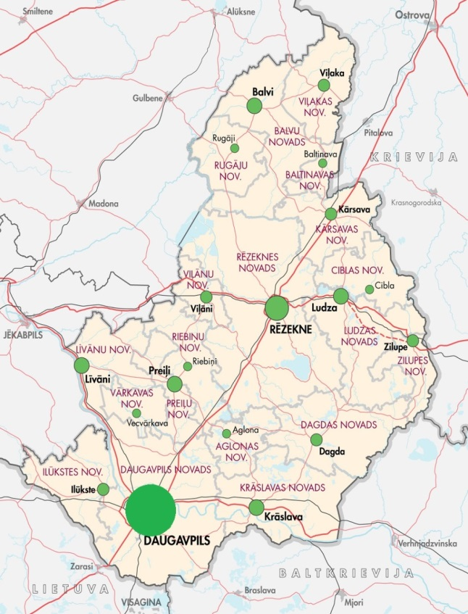 Aluksne and Gulbene in Vidzeme region. Latgale is connected with Vidzeme region towns Madona, Cesis, Gulbene, Aluksne and Valmiera by developed road network.

Territory of Latgale region occupies 22.5% of the entire area of the country. Proportion of residents in the total number of residents nationwide was 14.55% at the beginning of 2014.

*Figure 3:*

*Latgale regional municipal administrative centres*

*(Data: SIA „Grupa 93”)*

## Transport and logistic infrastructure

*Roads*

Latgale is crossed by three roads of national importance and also three roads of international importance:

* A6 Riga-Daugavpils-Kraslava-Border of Belarus (Pāternieki)
* A12 Jekabpils-Rezekne-Ludza-Border of Russia (Terehova), which is a part of the European road network E22 (Holiheda-Ventspils-Riga-Velikije Luki-Moscow-Vladimir-Nizhny Novgorod)
* A13 Border of Russia (Grebneva)-Rezekne-Daugavpils-Border of Lithuania (Medumi), which is a part of the European road network E262 (Kaunas-Ukmerge-Daugavpils-Rezekne-Ostrova).

*Railway traffic*

Latgale region is crossed by several railway lines of international importance:

* Maskava–Zilupe–Rezekne-Krustpils–Jelgava-Ventspils;
* Vitebska-Indra–Daugavpils-Krustpils-Riga;
* St.Petersburg-Karsava-Rezekne-Daugavpils-Eglaine-Klaipeda/Kurcums -Vilnius.

Railway corridors are situated in parallel with the three main roads, thus strengthening the role of Rezekne and Daugavpils as important regional hubs.

*Air traffic*

Daugavpils airport, which is certified as a general aviation aerodrome, is located in the region. Regular flights are operated here by sports, medical aid, military and dusting planes.

Aerodrome in Rezekne is being used for training flights only.

International airports at the closest distance from Latgale region are located in Riga (approximately 250 km from Rezekne and Daugavpils), as well as in Vilnius and Kaunas in Lithuania (approximately 200 km from Daugavpils and over 300 km from Rezekne).

Work on development of design of the regional airport in Daugavpils has been commenced. The airport is located at Naujenes parish, Lociku village, at 1 km distance from the main national road Border of Russia (Grebneva) - Rezekne - Daugavpils - Border of Lithuania (Medumi) (A13), which is a part of the road of European importance E262 Warszawa – St.Petersburg, and 1 km from the main national road Riga - Daugavpils – Kraslava - Border of Belarus (Pāternieki) (A6). The airport is located near the railway line Riga – Daugavpils – Indra. Location by important transport corridors makes the position of Daugavpils airport attractive. Land is the property of municipality. Total amount of the necessary investments is approximately 60 million euro.

Several voluminous researches regarding development opportunities of transport and logistic services in Latgale region have been executed. Conclusions regarding freight flows in Latgale region resulted from the research “Analysis of the potential of Latgale and Vidzeme regions, Pskov and Leningrad counties in the field of transport and logistics. Current trends and development opportunities” were as follows:

* Freight flow from the East to the West mostly moves along railway; from the West to the East – along roads; freight transport through the border of Latvia and Russia mainly consists of transit transport;
* Growing segment of railway transit consists of container transport related to increase of finished products import from the EU and Asia to Russia. This kind of transport will continue developing;
* Mostly finished products produced in the EU and destined for Russia are being transported along roads. There is fully reasonable ground to consider that volume of road transport in the direction from the EU to Russia will grow in short-term and medium-term perspective;
* The current road network in Latgale region allows doubling of the turnover of road transport provided that road surface will be improved and the section Ludza – Terehova will be reconstructed;
* Loading of railway infrastructure allows significant increase of freight flow through the region. Loading of several railway sections in the Eastern – Western corridor accounts for just 50%. Increase of the railway capacity is planned by increase of freight flows;
* Capacity of the main motor roads allows for at least double increase of transport causing no serious problems in Latgale region.

## Residents of the region

311 058 residents were registered in Latgale region at the beginning of 2015. Changes in number of residents from the beginning of 2009 until the beginning of 2014 show approximately 8% decrease of residents of Latgale.

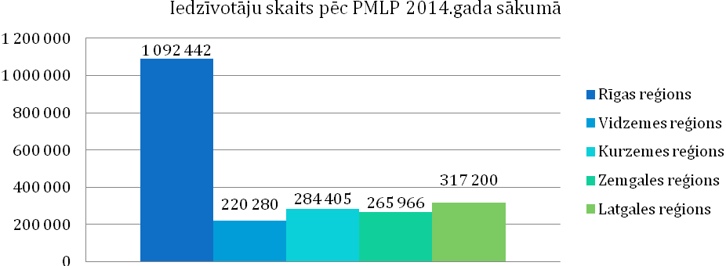

|  |  |
| --- | --- |
| Iedzīvotāju skaits pēc PMLP 2014.gada sākumā | Number of residents according to OCMA at the beginning of 2014 |
| Rīgas reģions | Riga region |
| Vidzemes reģions | Vidzeme region |
| Kurzemes reģions | Kurzeme region |
| Zemgales reģions | Zemgale region |
| Latgales reģions | Latgale region |

*Figure 4: Number of residents in the planning regions at the beginning of 2014*

*(Source: The Office of Citizenship and Migration Affairs)*

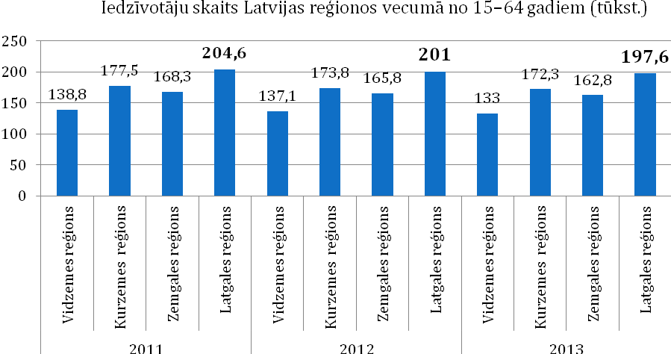

|  |  |
| --- | --- |
| Iedzīvotāju skaits Latvijas reģionos vecumā no 15-64 gadiem | Number of residents in the regions of Latvia, age group 15-64 |
| Vidzemes reģions | Vidzeme region |
| Kurzemes reģions | Kurzeme region |
| Zemgales reģions | Zemgale region |
| Latgales reģions | Latgale region |

*Figure 5: Number of residents in the planning regions 2011 - 2013*

*Source: Central Statistical Bureau of the Republic of Latvia*

### Education

***Secondary and secondary vocational education***

1672 students studied in the 12th grade of general education schools in Latgale region in 2014; they form basis for the studying youth of the region.

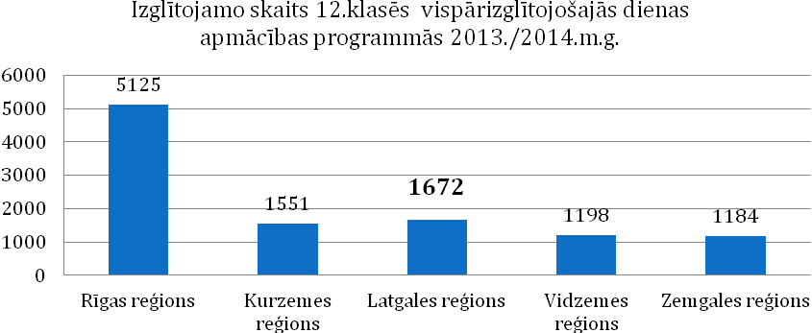

|  |  |
| --- | --- |
| Izglītojamo skaits 12.klasēs vispārizglītojošajās dienas apmācības programmās 2013./2014.m.g. | Number of students in 12th grades of full-time general education programmes in 2013/2014 school year |
| Rīgas reģions | Riga region |
| Vidzemes reģions | Vidzeme region |
| Kurzemes reģions | Kurzeme region |
| Zemgales reģions | Zemgale region |
| Latgales reģions | Latgale region |

*Figure 6: Number of students in 12th grades of full-time general education programmes in 2013/2014 school year*

*Source: Ministry of Education and Science of the Republic of Latvia*

Secondary vocational education can be acquired in the following specialities in Latgale:

* Vocational education programmes in the field of **mechanical engineering and metalworking** are being implemented in Daugavpils State Technical School (metal processor, turner, fitter, locomotive facilities technician, transport car technician, railway track facilities technician and rolling stock fitter).
* Vocational education programmes in the field of **construction** are being implemented in Dagda Vocational Secondary School (finishing work worker), Daugavpils State Technical School (finishing work technician, finishing work worker, bricklayer, tile stove potter, sanitary equipment assembler, road construction technician), Rezekne Technical School (former Eastern Latgale Vocational Secondary School) (finishing work worker, builder of buildings, finishing work technician, woodworker, construction worker), Jaunaglona Vocational Secondary School (builder of log buildings, woodworker, repairer).
* Vocational education programmes in the field of **power industry, electronics and automation** are being implemented in Latgale Transport and communication technical school (electrician), Rezekne Technical School (former Eastern Latgale Vocational Secondary School) (electrician), Daugavpils State Technical School (wireman).
* Vocational education programmes in the field of **machinery sciences** are being implemented in Dagda Vocational Secondary School (motor engineer), Daugavpils Technical School of Construction (car electrician), Jaunaglona Technical School (motor engineer), Daugavpils State Technical School (motor engineer, railway track facilities technician, locomotive facilities technician, transport car technician, railway transport safety technician, railway transport automation, telemechanics and communications technician), Rezekne Technical School (former Eastern Latgale Vocational Secondary School) (motor engineer, assistant motor engineer), Malnava college (motor engineer), Viski Vocational Secondary School (agriculture machinery mechanics).
* Vocational education programmes in the field of **production of foodstuffs** are being implemented in Rezekne Technical School (former Eastern Latgale Vocational Secondary School) (foodstuffproduction technician).
* Vocational education programmes in the field of **textile production** are being implemented in Rezekne Technical School (former Eastern Latgale Vocational Secondary School) (producer of sewn products, tailor), Daugavpils Vocational Secondary School No. 1 (assistant sewer, sewer, tailor), in Dagda Vocational Secondary School (tailor).
* Vocational education programmes in the field of **tourism and recreation organization and Hotel and restaurant services** are being implemented in Bebrene Vocational Secondary School (hotel service specialist), Dagda Vocational Secondary School (catering service specialist, cook assistant), Rezekne Technical School (former Eastern Latgale Vocational Secondary School) (catering service specialist, hospitality service specialist, cook), Viski Vocational Secondary School (catering service specialist), Daugavpils Trade Vocational Secondary School (cook, confectioner, restaurant service specialist), Preili Vocational Secondary School (cook).
* Vocational education programmes in the field of **wood processing** are being implemented in Daugavpils Vocational Secondary School No. 1 (assistant carpenter), Daugavpils State Technical School (cabinet-maker, carpenter) and Rezekne Technical School (former Eastern Latgale Vocational Secondary School) (cabinet-maker).
* Vocational education programmes in the field of **agricultural specialities** are being implemented in Malnava college (rural property manager), Viski Vocational Secondary School (rural property manager, agricultural machinery mechanic), Technical School (former Eastern Latgale Vocational Secondary School) (pisciculturist), Bebrene Vocational Secondary School (assistant veterinarian).

***Higher education***

Currently two regional institutions of higher education offer higher education in Latgale – Daugavpils University, Rezekne University of Applied Sciences – and branches of 13 other institutions of higher education of Latvia located in Daugavpils, Rezekne and Balvi.

**Daugavpils University** is the second largest classic type state university in Latvia. It keeps its development as an important scientific research centre in Latgale. Daugavpils University offers studies in 5 faculties:

* [The Faculty of Natural Sciences and Mathematics](http://www.du.lv/en/about_university/faculties/dmf)
* [The Faculty of Humanities](http://www.du.lv/en/about_university/faculties/hf)
* [The Faculty of Education and Management](http://www.du.lv/en/about_university/faculties/ivf)
* [The Faculty of Music and Arts](http://www.du.lv/en/about_university/faculties/mmf)
* [The Faculty of Social Sciences](http://www.du.lv/en/about_university/faculties/szf)

Daugavpils University implements measures to attract students from Latgale region, as well as from other regions of Latvia and foreign students. In order to satisfy the labour market demand in Latgale region, Daugavpils University expands opportunities of studies in various thematic fields and purposefully develops demanded programmes: in natural sciences and engineering sciences (*Environmental science, Environmental planning, Computer sciences, Physiotherapy, Information technologies, Solid State Physics and other)*, in social sciences by highlighting the importance of entrepreneurship in the development of national economy and regional aspects (*Law, Law sciences,* [*Economics*](http://www.du.lv/lv/studijas/programmas/bakalaurs/ekonomika)*,* [*Carrier advisor and specialist of youth affairs*](http://www.du.lv/lv/studijas/programmas/profesionalais_magistrs/karjeras_konsultants_un_jaunatnes_lietu_specialists)*, Management sciences,* [*Psychology (social psychology)*](http://www.du.lv/lv/studijas/programmas/magistrs/psihologija)and other), in humanities by highlighting the international social economic cooperation (*Easter Europe Cultural and Business Connections, Interpreter (translator)* and other) and in art (*Design, Art management* and other).

Development of new inter-disciplinary study programmes are also in progress for preparation of more diversified specialists able to adapt better to the changeable social economic environment and labour market not only in Latvia, but also nationwide.

Several scientific institutes and centres are operating in Daugavpils University performing scientific research activities in various fields. *Institute of humanitarian and social sciences* has been established since 2014 by combining several former institutes and centres – Institute for Sustainable Education, Institute of Comparativistics, Social Research Institute and Latgale Research Institute. *Institute of Life Sciences and technologies* was established combining Institute of Ecology, Institute of Systematic Biology, G.Liberts Centre of Innovative microscopy and Mathematical Research Centre. Besides, *Oral History Centre* and *Institute of Art Sciences* operate in Daugavpils University.

**Rezekne University of Applied Sciences** is a state institution of higher education established on the basis of branches of the University of Latvia and Riga Technical University. Rezekne University of Applied Sciences implements study programmes, as well as is active in the field of science, research and artistic creative work. There are four faculties in Rezekne University of Applied Sciences:

* **Faculty of Education and Design**,
* **Faculty of Humanities and Law**,
* **Faculty of Engineering**,
* **Faculty of** Economics and Management.

Task of Rezekne University of Applied Sciences – improvement of proportion of the residents with higher education in Rezekne city and Latgale region, as well as attraction of secondary schools graduates to studies and – after the studies are finished – to work in Latgale region.

Rezekne University of Applied Sciences has established tight cooperation with local governments. RA Convention consists of heads of local governments and entrepreneurs from Latgale region. Together with local governments RA has developed projects of national importance, for example, project of Rezekne Special Economic Zone.

Rezekne University of Applied Sciences provides further education opportunities by offering on average 20 – 30 courses and programmes of professional improvement and further education annually.

Four scientific institutes for the development of scientific activity have been established in Rezekne University of Applied Sciences:

- Latgale sustainable development research institute (LIAPI),

- Latgale national economy research institute (LTPI),

- Personality socialization research institute (PSPI),

- RA Institute of Letonica (RALI).

Besides the two previously mentioned institutions of higher education based within the region studies in Latgale are provided by a number of branches of the institutions of higher education established by legal entities and natural persons from the capital (Baltic International Academy, The University College of Economics and Culture, Information Systems Management Institute, The Art Academy of Latvia, University of Latvia, Customs college, Higher School of Psychology, Riga Aeronautical Institute, Riga Technical University, Higher School of Social Technologies, Transport and Telecommunication Institute, Higher School of Management and Social Work “Attīstība” [“Development”], State Border Guard College).

Large part of the study programmes is suitable also for the specific requirements of the labour market. For example, Latgale branch of Transport and Telecommunication Institute offers to residents of the region higher vocational education in the following study programmes: “*Transport and business logistics”* and *“Transport entrepreneurship management”*, as well as bachelor degree in study programme *“Transport commercial exploitation”*. A new programme has also been developed, which, upon studying in Daugavpils for the entire period of studies provides opportunity to acquire academic degree *“Bachelor of Engineering Sciences in Machine Science”*. Speciality of this programme called *“Overground transport exploitation”* has been prepared especially for Latgale branch. The programme has been developed taking into consideration the regional specificities and recommendations of the specialists working in the sector of transport companies. This is the basis of the education of engineer. Over 65% of the load of studies have been assigned for the acquirement of classical subjects of engineering sciences and approximately 35% - for the subjects related to management, economics, languages and other. The entire process of studies takes place at TSI Latgale branch, furthermore, material facilities of Latgale transport and telecommunications technical school and “Daugavpils Locomotive Repair Plant” and modern computer technologies are being used. Traineeship takes place at “Latvijas Dzelzceļš” and “Daugavpils autobusu parks”, as well as other transport enterprises of Latgales region.

***Lifelong education***

In comparison with other regions of Latvia higher activity in the field of lifelong education (adult education) [3] can be observed in Latgale. In 2011 the highest percentage of adults (excluding Riga and Greater Riga region) were involved in acquirement of both formal and informal education. Although no statistical data regarding the very recent years are available, situation could be similar. It has been observed that women are more active than men in the field of lifelong education.

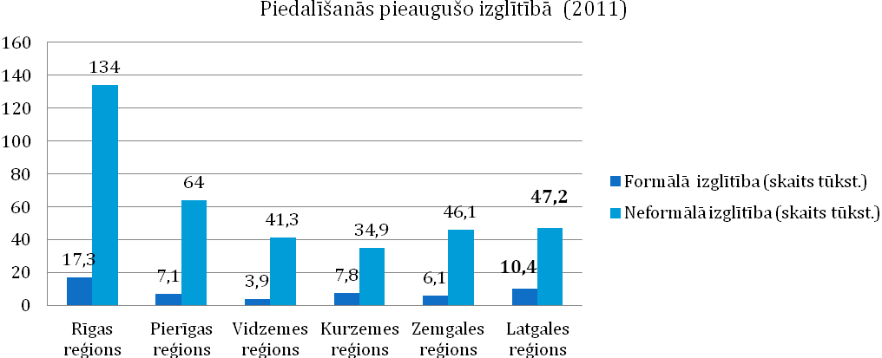

|  |  |
| --- | --- |
| Piedalīšanās pieaugušo izglītībā (2011) | Participation in adult education (2011) |
| Rīgas reģions | Riga region |
| Pierīgas reģions | Greater Riga region |
| Vidzemes reģions | Vidzeme region |
| Kurzemes reģions | Kurzeme region |
| Zemgales reģions | Zemgale region |
| Latgales reģions | Latgale region |

*Figure 7:* *Participation in adult education (2011)*

*Source: Central Statistical Bureau of the Republic of Latvia*

### Unemployment and job seekers

Rate of the registered unemployment was 8.5% nationwide on 31 December 2014 (proportion of the registered unemployed persons within the total amount of economically active residents). The highest unemployment level was just in Latgale region (17.8%), where the total number of unemployed persons was 23981.

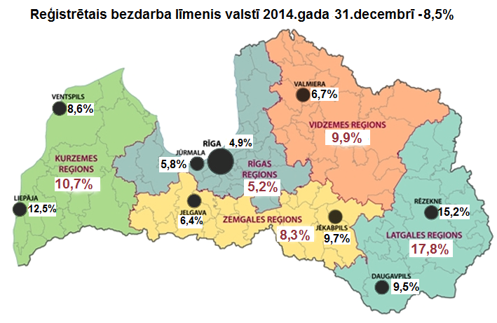

**Rate of the registered unemployment nationwide on 31 December 2014 - 8.5%***Figure 8: Rate of the registered unemployment nationwide**and in regions in December of 2014*

*(Source: Data of SEA)*

According to the data provided by the Central Statistical Bureau of the Republic of Latvia there were approximately 2300 active job seekers with higher education, 7900 job seekers with vocational education or vocational secondary education and approximately 8000 job seekers with general higher education.

Taking into consideration the available re-training measures for unemployed persons the potential labour force of approximately 20 000 is available in the region.

## Enterprises and non-financial investments

Entrepreneurship environment of Latgale planning region is not much different from other regions, however, such individualities of the region as lower value added of the finished products, lower purchasing capacity of residents and higher rate of self-employed persons should be noted.

There were 48 economically active statistical units of market sector per one thousand residents in Latgale region in 2013.

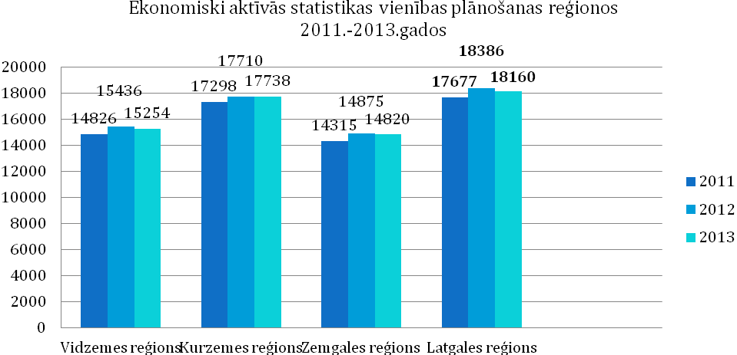

|  |  |
| --- | --- |
| Ekonomiski aktīvās statistikas vienības plānošanas reģionos 2011-2013 | Economically active statistical units in the planning regions 2011-2013 |
| Vidzemes reģions | Vidzeme region |
| Kurzemes reģions | Kurzeme region |
| Zemgales reģions | Zemgale region |
| Latgales reģions | Latgale region |

*Figure 9: Statistical units of market sector* *(self-employed persons, individual merchants, commercial companies, farms and fishing enterprises) Source: Central Statistical Bureau of the Republic of Latvia*

In comparison with other regions self-employed persons accounted for the highest rate of the economically active statistical units of market sector in Latgale region in 2013 significantly exceeding the average rate of Latvia (34.0%). This indicator could show the activity of the residents of Latgale region and their wish to improve their life conditions, as well as this is a way to create job for himself/herself, since the unemployment rate in Latgale is currently the highest nationwide.

There are several enterprises working in Latgale region and producing not only for internal market, but also successfully exporting their products, including LLC (SIA) “Intergaz”, LLC (SIA) “Axon cable”, LLC (SIA) “Zieglera mašīnbūve”, JSC (AS) “Preiļu siers”, LLC (SIA) “Zilā lagūna”, LLC (SIA) “Magistr”, LLC (SIA) “Belmast”, JSC (AS) “Daugavpils lokomotīvju remonta rūpnīca”, LLC (SIA) “Nexis Fibers”, LLC (SIA) “STARS MET”, LLC (SIA) “Z-Light”, LLC (SIA) “Līvānu kūdras fabrika”, LLC (SIA) “Nemo” and other enterprises. For several years a number of enterprises registered in Latgale region have also been among the 100 largest exporters of Latvia. JSC (AS) “Preiļu siers” located in Latgale region was awarded in TOP 500 nomination “TOP regional enterprise” in 2014.

According to the data provided by the Central Statistical Bureau of the Republic of Latvia non-financial investments in Latgale region reached 433.5 million euro in 2013 showing 27.41 million euro growth in comparison with 2008. This indicates on the economical potential of Latgale, as well as necessity to continue additional state-level support for the improvements of the region.

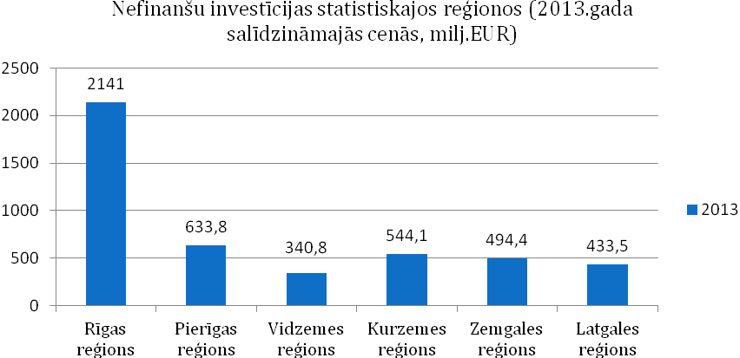

|  |  |
| --- | --- |
| Nefinanšu investīcijas statistiskajos reģionos (2013.gada salīdzināmajās cenās, milj. EUR) | Non-financial investments in the statistical regions (in reference prices of 2013, million EUR) |
| Rīgas reģions | Riga region |
| Pierīgas reģions | Greater Riga region |
| Vidzemes reģions | Vidzeme region |
| Kurzemes reģions | Kurzeme region |
| Zemgales reģions | Zemgale region |
| Latgales reģions | Latgale region |

*Figure 10: Non-financial investments in the statistical regions (in reference prices of 2013, million EUR)*

*Source: Central Statistical Bureau of the Republic of Latvia*

According to the information from Lursoft data base, so far manufacture and wholesale have been the most attractive sectors for the direct foreign investments. Manufacture of other vehicles sector has attracted 13.27% of all direct foreign investments in Latgale planning region (EUR 10 457 642.53), manufacture of chemical products and goods– 6.9%, wholesale – 5.2% (EUR 4 108 499.71), while manufacture of wood products – 5.0% (EUR 3 955 435.60).

The most significant clusters in Latgale region (proportion within the region in comparison with the proportion nationwide by the number of employed persons):

* manufacture of equipment and electric equipment;
* manufacture of other vehicles.

Largest investment flows arrive to Latgale planning region from neighbouring countries of Latvia – Russia and Estonia. Investors from Russia form 43% of the total number of investors, while investors from Estonia – 16% of the total number of investors. The following highest number of investors in Latgale planning region is from Germany, Switzerland, Lithuania and Denmark. Investors from these countries form more than 23% of the total number of investors within the region.

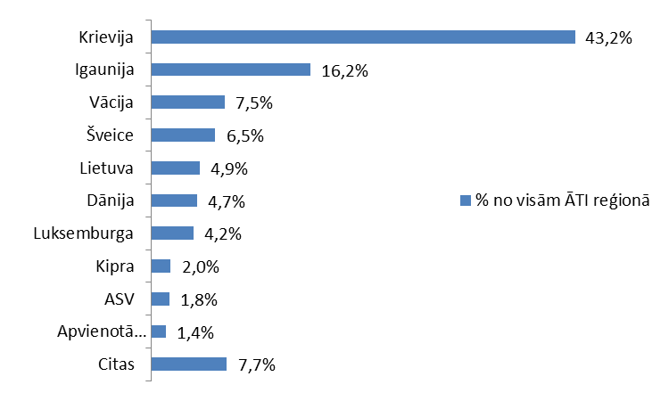

|  |  |
| --- | --- |
| Krievija | Russia |
| Igaunija | Estonia |
| Vācija | Germany |
| Šveice | Switzerland |
| Lietuva | Lithuania |
| Dānija | Denmark |
| Luksemburga | Luxembourg |
| Kipra | Cyprus |
| ASV | USA |
| Apvienotā Karaliste | United Kingdom |
| Citas | Other |
| % no visām ĀTI reģionā | % of all direct foreign investments in the region |

*Figure 11: Distribution of investors by countries, 1994-2014 (Source: Lursoft)*

|  |  |  |
| --- | --- | --- |
| **Positive advantages for investments in Latgale region** | * Location in the single EU market and by the EU border * Availability of qualified labour force in sufficient numbers * Foreign language skills of residents (more than 90% residents of Latgale have a command of at least one foreign language) * Multi-national, tolerant society, multi-language, multi-cultural environment * Availability of the EU co-financing for the local governments for the adjustment of territories, construction of buildings * Corporate income tax nationwide (15%) * Lower labour force costs than on average in the EU * Good connections with Russia and Belarus * Comparatively good road coverage (including the highest proportion of roads with black surface nationwide among regions – 50.2%, however, with variable quality) * Second highest proportion of labour force with secondary education nationwide among regions – 57.9% * Higher concentration of enterprises in sectors of manufacture of equipment, electric equipment and other vehicles than in other regions of Latvia * Access to natural resources - turf, sapropel, wood * Developed logistics allowing attraction of partners in the EU and Russian markets * Rezekne Special Economic Zone – favourable environment for investments and the development of entrepreneurship * Developed capacity of projects in municipalities of cities of national and regional importance * Significant investments in the education infrastructure in recent years (investments in both the institutions of vocational education and the institutions of higher education in Latgale region) * Wide coverage of internet and high internet speed | |
| Perspective sectors[4]  *(Source: Investment and Development Agency of Latvia, “Strategy for Investment Attraction to Urban Areas in LV-LT Cross-border Region” and “Programme of Latgale 2010 – 2017”)* | | * Wood processing and manufacture of wood products * Metalworking and mechanical engineering * Transport and logistics * Information technologies * Food industry * Life sciences * Healthcare * Green technologies * Manufacture of equipment, manufacture of transport and electric equipment * Manufacture of textiles and clothing |

**Cross-border cooperation opportunities**

Taking into consideration proximity of the border additional strengthening of cooperation between the existing institutions in Latgale and Utena/Ignalinas county in Lithuania is possible (for example, between Latgale planning region and Ignalinas nuclear power station region business incubator), as well as between the enterprises located in the borderland. The existing cooperation links between the enterprises may be identified and possible cooperation options in manufacture sectors in the future may be assessed (for example, identification of sectors, where the region exports components of certain product and assessment of opportunities regarding manufacture of other ingredients of the product in the region concerned; or specialist exchange and labour force rent service opportunities).



|  |
| --- |
| **Latgale-Ignalinas nuclear power station (Visaginas) region investment attraction centres*:**  - Industrial park  - Vocational education institutions  - Institutions of higher educations  - Knowledge transfer centres  **Complementary manufacture centres**  - Logistic park  - Vocational education institution  * In Visaginas  Manufacture of wood products  Production of foodstuffs  Mechanical engineering and manufacture of equipment  Power industry services and products  Manufacture of textiles and clothing  Manufacture of metal and metal products  Manufacture of electric equipment |

*Figure 12: Concept map for creation of sinergies in Latgale-Ignalinas nuclear power station (Visaginas) cross-border region*

*Source: “Strategy for Investment Attraction to Urban Areas in LV-LT Cross-border Region”*

## Public support to the entrepreneurship

In order to promote settlement and development of the municipal infrastructure (including entrepreneurship territories) it is planned to commence a new EU fund activity in 2015 including the Specific support goal (SAM) 5.6.2 “Investments in revitalization of degraded territory in Latgale planning region and Aluksne district municipalities”. It is foreseeable that the investment promotion projects will mobilize for entrepreneurship all the current resources of Latgale – enterprises, municipalities and people.

In 2015-2023 local governments of Latgale region plans to invest all together in Latgale region more than 52 million euro for the settlement and revitalization of degraded territories significant for entrepreneurship, including dismantling of buildings, improvement of the existing premises, improvement of squares, aerodromes and industrial territories, creation and/or adjustment of new industrial territories (land areas, buildings and premises), establishment of new engineering communications and connections, reconstruction of streets, roads and bridges.

By using local natural conditions, the EU borderland, the developed logistics and qualified human resources these municipal projects will reduce the negative trends as much as possible, follow and integrate in the development processes of Latvia and the European Union.

There are several national level business and entrepreneurship support institutions operating in Latgale region.

Latvian Chamber of Commerce and Industry and Employers’ Confederation of Latvia have branches in Rezekne and Daugavpils, as well as business support institutions have been established in municipalities (business information or support centres – as separate structural units or municipal specialists, as well as mutual or tripartite advisory councils).

**Business incubators and technology transfer points –** operate to promote establishment and development of new, viable and competitive merchants in Latgale region providing environment required for commercial activity and advisory services.

**Innovation centre of Rezekne University of Applied Sciences** – supports establishment of new, innovative enterprises and provides initial support for start-up. Commercial companies can receive the following services in the Innovation centre of Rezekne University of Applied Sciences:

* Infrastructure services – equipped office premises (furniture, internet, phone, meeting room, kitchen and toilet facilities). Office premises with 18 m2 and 36 m2 area are available;
* Unified services of secretariat and office (fax, copying, processing of incoming and outgoing correspondence and other services);
* Entrepreneurship support services – registration of commercial company, accounting services, drawing up of legal documents, marketing consultations, drawing up of business plans, attraction of the EU structural funds;
* Technological services – designing and development of prototypes of new products and the first experimental models.

**Līvāni Engineering and Innovation Centre (LIIC)** – provides support for the existing town and district enterprises and promotes creation of new ideas and products, as well as establishment and development of new, viable and competitive enterprises in Latgale region. LIIC provides environment necessary for entrepreneurship (rent of premises and equipment, office and other services) and advisory services on matters related to start-up and development of entrepreneurship. LIIC also organizes measures for the increase of youth’s interest and understanding about entrepreneurship on regular basis.

**Technology transfer contact point of Daugavpils University** – goal of its operation is initiating, support and promotion of transfer of knowledge and technologies. This contact point offers:

* informative, methodological and scientific support for the technology transfer process;
* informative support: publications, conferences, exhibitions;
* intellectual property protection services (search for analogues and prototypes, preparation and submission of patent applications);
* promotion of highly technological enterprises and organizations in local and international market;
* measures related to technologies’ export, realization, including conducting of negotiations, conclusion of contracts.

**Environmental technology transfer contact point of Rezekne University of Applied Sciences** is a structural unit of the Sustainable development research institute of Faculty of Engineering of Rezekne University of Applied Sciences providing commercialization of innovative activities in the field of environmental technologies, which promotes implementation of the up-to-date scientific, technical, social or other ideas, elaborations and technologies in a product or service, which is competitive and demanded in the market.

1. **REZEKNE in the regional context of Latgale**

Rezekne, which is located at the centre of Latgale and is well reachable from various points of the region, is significant as the **centre of economic development and services of the region**. Rezekne is the second largest industrial centre in Latgale, as well as significant centre of social economic development and culture within Latvia.

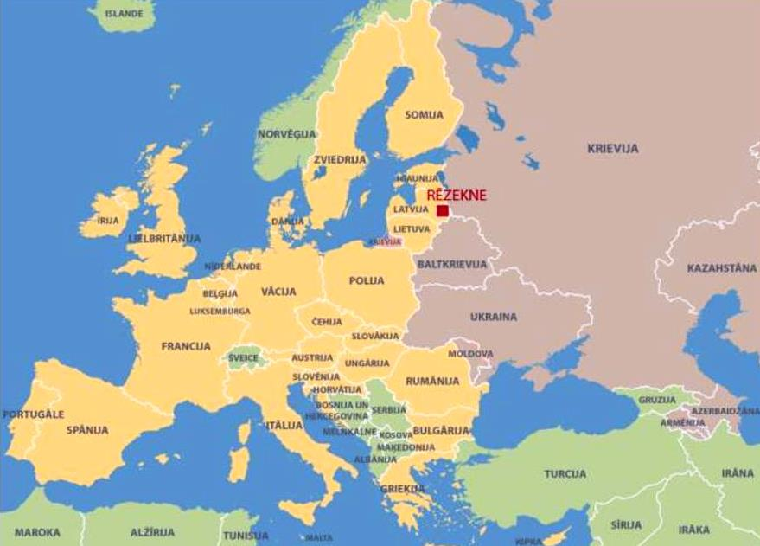

*Figure 13: Location of Rezekne city in the European map*

Rezekne is the guide of economic development of the region, a **development centre of national importance** with integrated infrastructure and network of services, where recipients of public services include not only residents of Latgale region, but also residents of other regions of Latvia. Rezekne offers public services also to the residents of the districts of neighbouring regions: Madona, Aluksne and Gulbene.

Rezekne city is a significant **nationwide** **transport hub**. It is crossed by strategically important roads and railway lines.

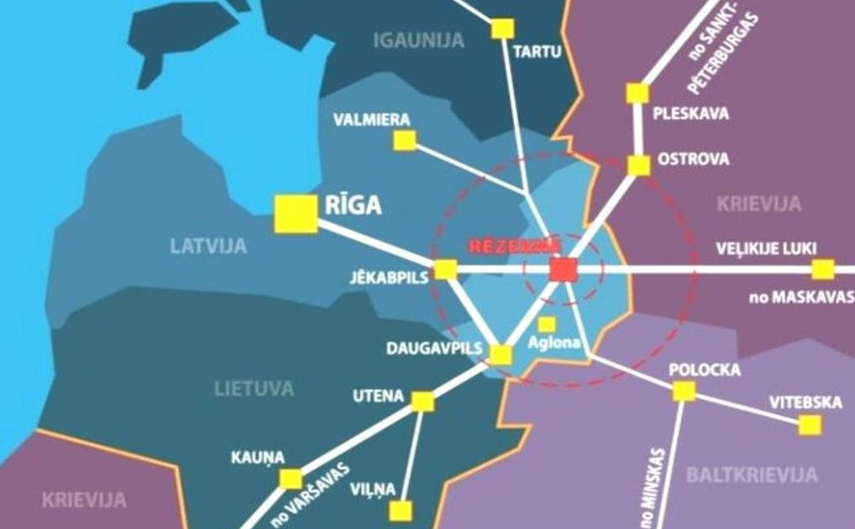

*Figure 14: Transport main roads and connections*

Rezekne is located **at the junction** of two strategically important **transport main roads and railway lines** (Riga – Moscow and St.Petersburg – Warsaw) and by transport corridors of international importance (A12/E22, A13/E262, which are also corridors of the EU TEN). The city enjoys very favourable geographical situation of the territory – proximity of borders of three countries. The city is located geographically close to the border with Russia, Lithuania and Belarus and has become a border city of the EU and NATO with the East. Rezekne is located at the distance of 242 km from Riga, at the distance of 685 km from Moscow, at the distance of 450 km from St.Peterburg and at the distance of 860 km from Warsaw.

Role of industry has decreased and importance of services sector has grown within the last twenty years in the economics of Rezekne city. Economic structure of the city has been based on **services**. Public sector explicitly dominates in terms of employment. Pursuant to the industrial policy of Latvia in the future Rezekne will promote the structural changes of economics to produce goods and services with **higher added** **value** and export value.

**Fields of specialization** of Rezekne city (according to Rezekne city sustainable development strategy 2030) are:

* metal working and mechanical engineering,
* wood processing,
* tourism industry, including cultural tourism, healthy lifestyle and SPA services,
* production of foodstuffs, including industrial production of foodstuffs and beverages,
* home production,
* logistics, including transport and storage,
* works of hardware and apparatus/manufacture of apparatus and hardware/works of apparatus
* information and communications technologies (production and assembly),
* “green” city, including eco – construction, use of renewable energy, energy efficiency, as well as
* creative industries, sports and education services.

 

*Figure 15: Rezekne city is characterized by developed manufacture and diversified public services*

Education institutions in Rezekne: Rezekne University of Applied Sciences, branches of 5 institutions of higher education of Latvia, Rezekne State Border Guard College, Rezekne Technical School and other.

Rezekne University of Applied Sciences provides studies under 39 study programmes, including 21 bachelor’s degree study programmes, 15 master’s degree study programmes and 3 doctoral study programmes, total number of students exceeds 2000.

Rezekne Technical School (former Eastern Latgale Vocational Secondary School) provides vocational education in 31 programmes to over 1200 students (motor transport, food technology, hospitality, wood processing and other).

Rezekne is a significant **centre of culture**. All cultural and arts sectors are represented and developed in the city, including professional culture, traditional culture and amateur art, music and dance, theatre, literature, such as writing of Latgallian language writings and publishing, visual art, libraries, museums and the material and non-material cultural heritage typical for Latgale district.

Regional multi-functional centre of Eastern Latvia or “Latgale embassy GORS” positively impacts availability of culture services in the region and in interaction with other sectors of the national economy it promotes social and economic development of the region, as well as stimulates attraction of tourists thereto. Territory of the direct target region of GORS includes the territory of Eastern Latvia.

**Entrepreneurship support institutions** form not less important resource for the development of municipality. Several entrepreneurship support institutions operate in the city territory – Rezekne Special Economic zone (RSEZ), Employers’ Confederation of Latvia, Rezekne Society of Entrepreneurs, Latvian Chamber of Commerce and Industry Rezekne branch, Business incubator “Ideju Viesnīca” [“Hotel of Ideas”], society “Latgales aparātbūves tehnoloģiskais centrs” [Latgale technological centre for works of apparatus].

**Importance of RSEZ operation** must be especially highlighted among the development resources of the municipality. It was established in 1997 pursuant to Rezekne Special Economic Zone Law, and tax relief will be applicable there until the end of 2035. Goal of the zone is promotion of trade, development of industry and transport, as well as export and import of goods through Latvia attracting investments for the development of industry and infrastructure and creation of new jobs.

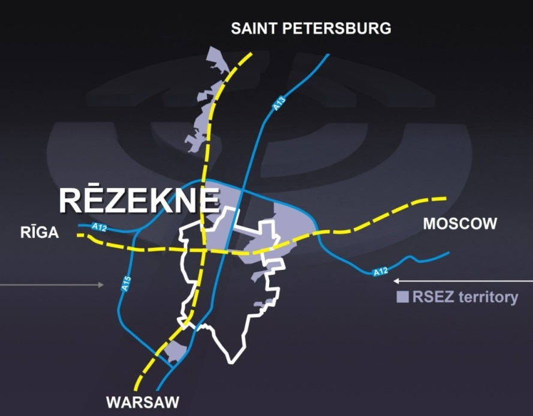

*Figure 16: The favourable geographical situation of RSEZ (marked with white line)*

Total area of RSEZ is 1 155.28 ha – 36% of the total area are located in the administrative territory of Rezekne city. Advantages of RSEZ operation include stable cooperation traditions with Russia, Belarus and a number of Member States of the EU, as well as competitive production costs within the context of Europe. Availability of human resources and quality provides by successful cooperation with education institutions both in Rezekne city and Latgale region forms very significant advantage.

Strong traditions of industrial production, recognizable enterprises, competitive production costs, proximity of local resources (timber, agricultural products, mineral deposits and other) – all this forms potential development resource of Rezekne city local government.

Rezekne is in possession of many strategic advantages and wide influence area.

|  |  |
| --- | --- |
| **Rezekne and its influence area**  Distance to Riga | 242 km |
| Distance to the nearest national importance development centre | 91 km |
| Distance to the nearest regional importance development centre | 26 km |
| The nearest national importance development centre | Daugavpils |
| The nearest regional importance development centre | Ludza |
| Districts within the influence area | Rezeknes, Vilanu, Karsavas (except Merdzenes parish), Zilupes, as well as Andrupenes, Andzelu, Ezernieku, Skaunes parishes in Dagda district |
| Number of residents in the development centre (OCMA data on 01.01.2015) | 31886 |
| Number of residents in the influence area of the development centre (including the centre) | 83 983 |
| Area of the development centre | 18 km2 |
| Area of the influence area of the development centre | 4162 km2 |

Wide **housing fund**, as well as competence of the existing enterprises and human resources is available in the city. The insignificant distance to the borders of foreign countries is additional advantage. Significant advantage is also the wide language knowledge of residents, thus facilitating the cooperation with residents and enterprises of the neighbouring countries.

The local government actively improves the urban area attracting national funding and funding of the EU funds. Budget of the local government is aimed at the development of infrastructure, education and social security. Today economics of cities is exposed to rapidly changing market conditions, but Rezekne can become a part of international market provided it exceeds the previously common regional level.

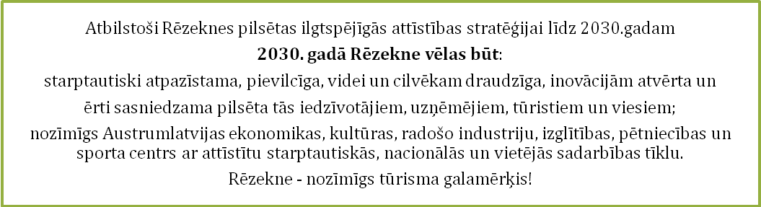

|  |
| --- |
| According to Rezekne city sustainable development strategy 2030  **in 2030 Rezekne wants to be:**  internationally recognizable city, attractive, friendly to environment and humans, open to innovations and conveniently reachable to its residents, entrepreneurs, tourists and guests;  important economics, culture, creative industries, education, research and sports centre of Eastern Latvia with developed international, national and local cooperation network.  Rezekne – important tourism destination! |

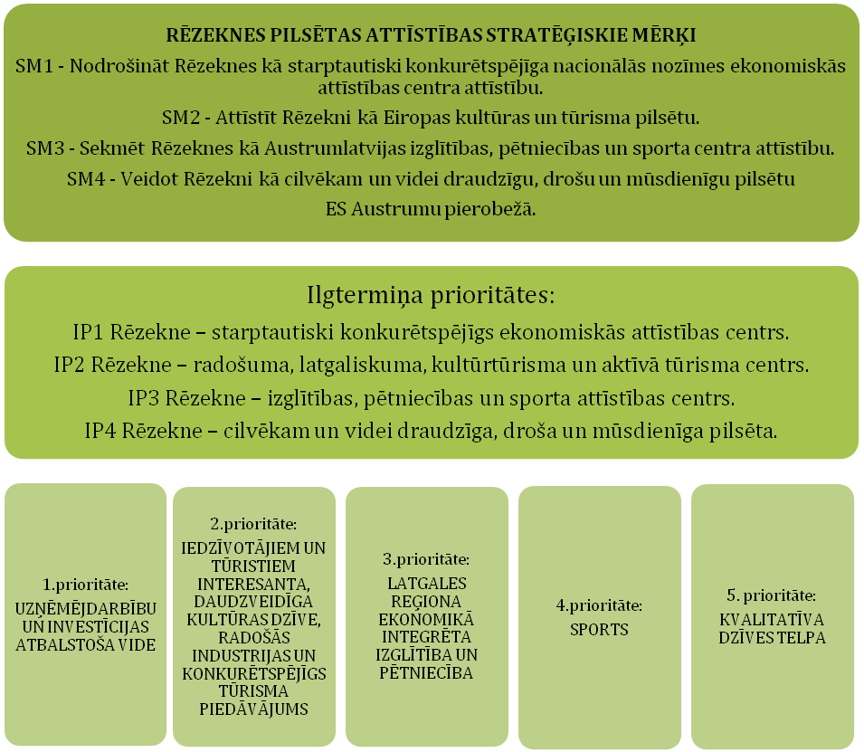

|  |  |  |  |  |
| --- | --- | --- | --- | --- |
| **STRATEGIC GOALS OF REZEKNE CITY DEVELOPMENT**  SM [STRATEGIC GOAL] 1 – Provision of development of Rezekne as an internationally competitive economic development centre of national importance.  SM [STRATEGIC GOAL] 2 – Development of Rezekne as a city of European culture and tourism.  SM [STRATEGIC GOAL] 3 – Promotion of the development of Rezekne as education, research and sports centre of Eastern Latvia.  SM [STRATEGIC GOAL] 4 – Formation of Rezekne as a city, which is friendly to humans and environment, safe and modern in the Eastern borderland of the EU. | | | | |
| Long-term priorities:  IP [long-term priority] 1 Rezekne – internationally competitive centre of economic development.  IP [long-term priority] 2 Rezekne – centre of creativity, latgallity, cultural tourism and active tourism.  IP [long-term priority] 3 Rezekne – education, research and sports development centre.  IP [long-term priority] 4 Rezekne – city, which is friendly to humans and environment, safe and modern. | | | | |
| Priority 1:  ENVIRONMENT SUPPORTING ENTREPRENEURSHIP AND INVESTMENTS | Priority 2:  VARIED CULTURAL LIFE, WHICH IS INTERESTING TO RESIDENTS AND TOURISTS, CREATIVE INDUSTRIES AND COMPETITIVE TOURISM OFFERS | Priority 3:  EDUCATION AND RESEARCH INTEGRATED INTOP ECONOMICS OF LATGALE REGION | Priority 4:  SPORT | Priority 5:  GOOD QUALITY LIVING SPACE |

*Figure 17: Future development vision and medium-term priorities of Rezekne city*

*Source: “Rezekne city development programme 2014–2020”*

*More information about the city: www.rezekne.lv*

*“Rezekne city development programme 2014–2020”*

# Description of the investment project for REZEKNE industrial zone [5]

## Name of the urban area industrial zone

**Rezekne city municipality owned properties at** Rezekne special economic zone (RSEZ)

## Location, area, zoning

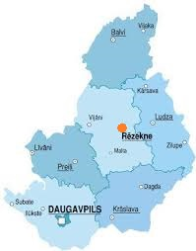 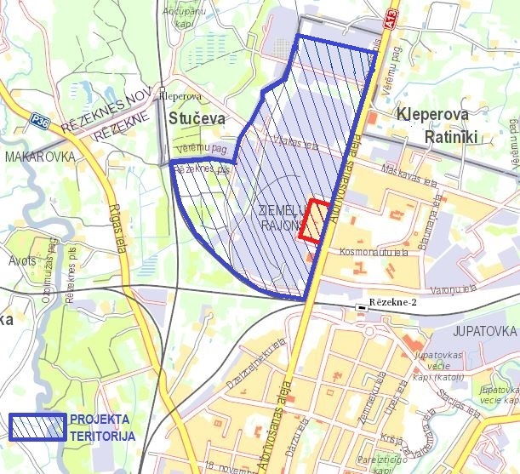

*Figure 18: Rezekne city in Latgale Figure 19: Location of the territory for industrial and warehouse building in Rezekne*

Address of the industrial territory: potential industrial zone (including the land plots owned by local government and available to investors) is located in the former industrial territory in the Northern district of Rezekne city and bordering with

* the territory of the LLC (SIA) “New Fuels” by Ziemelu Street in the Northern part of the investment project territory,
* Komunala Street bordering with the investment project territory in the Eastern and Southern parts,
* Atbrivosanas aleja bordering with the project territory from the East.

Besides, the project territory includes also properties located in the direction towards the city border and railway from Komunālā Street.

Total area of the land plots owned by the local government and located in the industrial territory: 22.7 ha

Land plots are located in various places of the industrial territory.

Zoning according to Rezekne city territory planning: territory for industrial and warehouse building

## Property rights

Land plots located in the industrial territory are owned by various owners, including:

Rezekne city local government, Rezekne city capital company “Rēzeknes Siltumtīkli”, State Joint Stock Company (VAS) “Privatisation agency”, RSEZ Rebir, JSC (AS) “LATVENERGO”, State Joint Stock Company (VAS) “Latvijas dzelzceļš”, natural persons and legal entities, as well as by the state. Accurate plan of land ownership is available in Rezekne city local government.

Territory is included in Rezekne special economic zone (RSEZ). RSEZ authority is a joint municipal institution under supervision of Rezekne City Council and Rezekne district Council.

## Entrepreneurship sector

Prior territories to be developed are related to the development of the available land plots and product infrastructure for commercial activity of various sectors. Sectors to be developed are based on local and/or well available resources, as well as corresponding labour force availability in Rezekne. However, the main sectors to be prevailing in the long term are:

* 1. Wood processing and wood-pulp energy
  2. Metal working
  3. Logistic management (within context with export of the EU goods to former CIS countries)[6].

In any case creation of new jobs within context of creation of higher added value and lower impact on environment is more important than definition of priorities at sector or product level.

## General description and goals of the project

Goals of the investment zone development project are –

* Transformation of unutilised land plots owned by the local government at the total area of 22.7 ha into developed and available industrial territory with industrial buildings and warehouses, reconstructing streets and access roads and general improvements of the territory thus renovating a new industrial centre within city for leasing or sale;
* Promotion of formation of favourable entrepreneurship environment and economic activity in the territory of Rezekne city, later in the future – also potentially improving general availability of RSEZ infrastructure, as well as transport infrastructure and landscape of city environment.

The improved infrastructure promoting economic activity will provide development and availability of the existing and new enterprises, territorial growth facilitating environmental sustainability and creation of new jobs in Rezekne city.

## Description of the industrial zone

Project territory is located in the Northern part of Rezekne city. Total area of the territory is approximately 150 ha including the land plots owned by the local government at the area of 22.7 ha. The whole project territory is located in the territory of Rezekne Special Economic Zone (RSEZ).

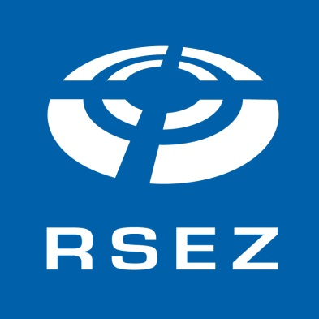RSEZ was established in 1997 with aim to promote trade, develop industry and transport, as well as export and import of goods through Latvia by attracting investments for the development of industry and infrastructure and creation of new jobs. The territory of RSEZ is fully subject to laws of the Republic of Latvia and other regulatory enactments. Special regulations for the commercial companies of RSEZ are provided pursuant to “Rezekne Special Economic Zone Law” and the law “[Application of Taxes in Free Ports and Special Economic Zones](http://www.vvc.gov.lv/export/sites/default/docs/LRTA/Likumi/Application_of_Taxes_in_Free_Ports_and_Special_Economic_Zones.doc)”. The commercial companies registered in RSEZ may be subjects to relief of direct taxes (real estate tax, corporate income tax), as well as indirect taxes by establishing free zones in the territory of RSEZ and investing resources.

Total area of RSEZ is 1155.28 ha including the administrative territory of Rezekne city and Rezekne district’s Veremu, Griskanu and Ozolaines parishes, including: territory 1 – 203.95 ha, territory 2 – 873.37 ha, territory 3 – 20.46 ha and territory 4 – 57.50 ha. Total area currently vacant and available for the development is ~645 ha.

RSEZ operation period will expire in 2035.

Advantages of RSEZ operation include stable cooperation traditions and competitive production costs within the European context. Availability and quality of human resources is a very significant advantage, and this is provided by the cooperation with education institutions. Capital companies registered in RSEZ may be subjects to relief of direct taxes (real estate tax, corporate income tax), and indirect taxes by establishing free zones in the territory of RSEZ and investing resources, as well as receive support from the RSEZ commercial activity support fund – support to projects of commercial companies was provided at the amount of 241 807 EUR (169 943 LVL) between 2007 and 2013.

Rezekne special economic zone provides direct access to international market with number of consumers exceeding 500 million. Being one of the most significant junctions of international transport main roads and railway lines in Latvia Rezekne is connected to the most important raw material resources and market of the European Union, Russia, CIS countries and Far East. The arranged road and railway infrastructure connects the Eastern border of Latvia with Russia and CIS countries thus providing to Rezekne a strategic opportunity to be a favourable intermediary for various transport flows with option of the necessary customs and other procedures.

Number of merchants currently operating in the project territory exceeds 100 (total turnover of the merchants was approximately 140 million EUR in 2013). Over 1100 employees of the territory work in Rezekne Northern industrial zone (RZIZ). This proves that also potential new merchants and investors have good opportunities to develop here.

Satisfaction of the local Latgale region entrepreneurs with environment of commercial activity is most closely related to access to local market, competitive real estate price and quality and infrastructure of the technical infrastructure.

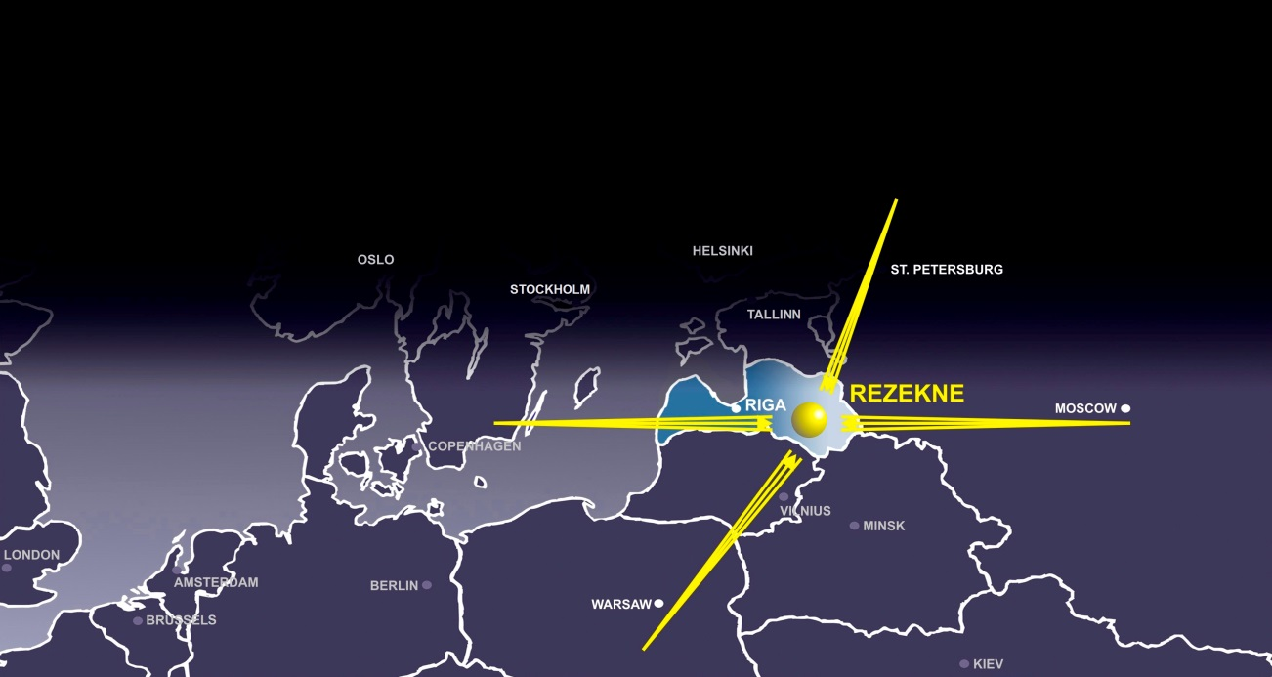

*Figure 20: Internationally strategic position of RSEZ*

Project territory is located in the proximity of the road A13 (Border of Russia (Grebneva)—Rezekne—Daugavpils—Border of Lithuania), as well as at the distance of approximately 2 kilometres from the road A12 (Jekabpils—Rezekne—Ludza—Border of Russia (Terehova)). Functioning railway branches connecting to railway lines in the directions of Riga (Ventspils, Liepaja), Daugavpils, Moscow and St.Petersburg are available in the territory.

Infrastructure and availability of communications in the industrial territory:

|  |  |  |  |
| --- | --- | --- | --- |
| *Type* | | | *Distance* |
| Access road ⌧ Asphalt 🞎 Gravel 🞎 Earth surface | | | 0.00km |
| Nearest roads | A 12 (Riga – Rezekne - Moscow)  A13 (Border of Russia (Grebneva) – Rezekne –Daugavpils – Border of Lithuania (Medumi)) | | |
| Nearest ports | Riga, Klaipeda | | 240km, 496km |
| Nearest cities Daugavpils | | | 90km |
| Railway ⌧ In the territory 🞎 Available 🞎 Non-available | | | 0.00km |
| International airports | Riga (LV), Vilnius and Kaunas (LT) | | 240km, 265km |
| General aviation aerodrome | | Daugavpils | 105km |
| Access to scientific personnel, advice | | Daugavpils, Rezekne | 90km, 2km |

|  |  |
| --- | --- |
| *Capacity / Type* | |
| Electricity | 110kV/10kV sub-station No. 91 is located in the project territory. Sub-station is located at the crossroads of Vilakas and Komunala streets with 110kV lead from the West. 110kV overhead line does not obstruct development of common development of the Project territory, since it has been located in cable shape along the railway in the section between Vilakas Street and Ziemelu Street 3, where the JSC (AS) “Sadales tīkls” is located.  10kV distribution networks in the Project territory and also in the Northern part of the city in general are provided from 10kV distribution points SP-2R and SP-3R. The abovementioned distribution points and 10kV feeding cables form property and responsibility of the JSC (AS) “Sadales tīkls”. The networks are in medium good condition and provide the territory with good quality electric power according to the regulatory enactments. Additional capacity for the development of new objects in each specific site should be analyzed separately, however, in general one can say that for the development of new and significant industrial projects (with the traditionally required 0.5 – 2 MW connection) capacity may be insufficient, and construction of new connection from the abovementioned sub-station located at Vilakas Street 9 may be required. |
| Gas | Gas supply of Rezekne city with natural gas is provided by the branch ‘Upmala – Preili – Rezekne’ with diameter 326 mm and pressure 2.5 MPa, connected to the main gas pipeline ‘Riga – Daugavpils’. Pressure reduction of natural gas pressure, accounting and distribution is provided by the gas regulation station (GRS) “Rēzekne” located at Ozolmuizas parish.  The high pressure P<1.6 MPa distribution system located in the Project territory has been constructed in 2005 and 2006:  - in 2005 high pressure distribution gas pipes D326 mm were constructed at Atbrivosanas aleja to Vilakas Street and at Vilakas Street to the branches towards the JSC (AS) “Rebir” located at Vilakas Street 4 and the JSC (AS) “Rēzeknes enerģija” at Atbrivosanas aleja 155A;  - in 2006 high pressure gas pipe D 219 mm was constructed at Atbrivosanas aleja to the branch towards the JSC (AS) “Rēzeknes Dzirnavnieks” at Atbrīvosanas aleja 167. |
| Sewerage | Rezekne city sewerage system is with capacity sufficient for provision of new connections, since there are sewerage water treatment plant (NAI) with capacity up to 12 000 m3/day in the city. Whole industrial zone is connected to centralized sewerage system. |
| Water | No centralized water supply system is provided for the industrial zone, since the complicated industrial territory infrastructure from soviet era has still remained. There are several separate local water supply systems for enterprises. Connection to city’s main water pipe is provided for separate enterprises. Technical designs for reconstruction of the streets located in the industrial territory provide construction of centralized water pipes that would provide water supply for enterprises in case of necessity. |
| Other | Connection to city’s centralized heating system is possible, if necessary. |

The most significant advantages of investors are indicated on page 14 of this document.

Rezekne Special Economic Zone provides for the entrepreneurs opportunity to gain significant profit based on favourable tax environment, competitive costs, adjustable labour force and other excellent advantages.

The key advantages are:

1) Location – geographic location at the junction of international roads and main railway lines, near the external border of the EU and location of RSEZ in the regional centre of culture and education, as well as attractive city environment;

2) Infrastructure – availability of railway network, use of city’s main engineering networks and availability of services;

3) Institutional environment and knowledge resources – wide network of the institutions of vocational education in Latgale, support from local governments and Rezekne University of Applied Sciences as the centre of engineering sciences in Eastern Latvia;

4) Resources (human resources, capital, natural resources and other) – strong traditions of industrial production, recognizable enterprises, competitive production costs, proximity of local resources (timber, agricultural products, mineral deposits and other);

5) Tax environment and regulatory framework (real estate tax relief, corporate income tax relief; free zone establishment opportunity in the territory of RSEZ for the enterprises allowing exemption of import and export transactions from customs tax and VAT).

*Direct tax relief[7]*

|  |  |  |  |
| --- | --- | --- | --- |
| Tax covered by the relief | Taxable object | Tax rate in Latvia | Tax rate operating with the status of RSEZ |
| Real estate tax | Cadastral value of land, buildings and structures | 1.5 % | 0-0,3 % |
| Corporate income tax | Gross margin | 15 % | 3 % |

Besides, the merchants of RSEZ may be subjects to the following *relief of indirect taxes* by establishing free zones in the territory of RSEZ, as well as investing resources:

#### 0% rate of value added tax shall be applied to the goods supply for RSEZ merchant in the free zone within RSEZ for further export;

#### exemptions from excise tax:

* oil products supplied to RSEZ merchant, while they are in the territory of the free zone of the RSEZ merchant.
* oil products used by the RSEZ merchant for production of electric power or in combined plants producing electric power and thermal energy.

Rezekne Special Economic Zone was ranked 6th globally in the category of cost efficiency within the questionnaire “Global economic zones in the future 2010/11” conducted by the issue “Foreign Direct Investment” of the British newspaper “Financial Times” involving independent experts analyzing special economic zones in 8 categories.

Besides, significant advantages to the investors will be provided after reconstruction of Daugavpils regional airport. The territory is located at the distance of 15 km from Daugavpils, by the motorways A13 and A7. On the basis of technical economical justification developed in 2012 reconstruction of Daugavpils regional airport and certification thereof for regular air traffic would take at least 2 years.

Natural persons and legal entities sell properties for situation of small production units, warehouses and office premises. Due to availability of the TEN-T network and national level motorways A12, A13 the territory is connected with the key main roads.

Local government of the city has undertaken to reconstruct roads and engineering communications with sufficient power to support the development of territory and to facilitate increase of production capacity of the current and new entrepreneurs for the development of current manufacture and attraction of new leaseholders.

Five largest groups of goods can be highlighted in the export structure of Latvian goods, which according to CSB data account for 70% of the total export of goods. Largest group (data of 2011) consist of wood-pulp and wood-pulp products (16.8%), nearly equal indicator with agricultural products and foodstuffs (16.4%), with metals and metal products lagging behind a bit (14.5%), while the share of mechanical engineering, electrical equipment, as well as chemical industry and its related industries is slightly lower (12.7% and 10.5% respectively). Structure of sectors (by revenue) of the manufacturing merchants in the Project territory is as follows provided that manufacture is identified separately:

* Wood processing and wood-pulp energy 43.5%;
* Mechanical engineering 26.4%;
* Textile industry 13.2%;
* Metal recycling and/or processing 8.9%;
* Other sectors 8.0%.

Upon comparison of the data concerning Project territory and Latvia in general high correlation is obvious (except for food industry), but relation of the leading sectors with the available resources in Rezekne city is explicitly obvious thus providing justified opportunities of economic development also for the young merchants.

## List of potential clients and cooperation partners

* Rezekne city local government
* Latgale Region Development Agency
* Regional business support organizations
* Investment and Development Agency of Latvia
* Private capital, including real estate developers
* Operator of the industrial zone
* Clients interested in purchase or lease of premises
* Clients interested in construction of new objects
* Enterprises already working in the Northern industrial zone
* Providers of further education services
* State Employment Agency
* Rezekne University of Applied Sciences
* Job seekers of Latgale region
* Manufacturers wishing to expand their activity in the Eastern Europe with direct access to the EU, small distance away from Russia and the borders of Belarus and qualified labour force.

## Summary of investments

Total amount of investments necessary for implementation of the investment project depends on the entrepreneurship sector chosen by the investor and the specificity.

Local government will invest in small and large scale infrastructure within limits in order to create favourable conditions for the investors, as well as examine its opportunities to provide financial stimuli and solutions in the field of human resources to improve the current condition of industrial territories and support measures for investors.

So far Rezekne city local government has fully reconstructed Atbrivosanas aleja, connections with streets in the Project territory have been established. The local government has financed development of the development concept of Rezekne city industrial territory and technical economic justification summarizing all the possible current information on engineering communications and buildings if the project territory; inspection of practically all land plots has been carried out; principal proposals for the development of territory have been prepared.

The local government has set following lines are priorities for the development of industrial zone:

1. adjustment of industrial zone (roads, communications (water pipe, sewerage, gas and other), parking lots, melioration, premises and other);
2. arrangement of roads and engineering communications (electricity, water supply pipe, sewerage, gas, lighting and other) to the industrial objects (outside industrial zones);
3. development of the market of industrial premises and areas.

Calculation of total amount of investments necessary for full arrangement of industrial zone is based on the document “Development concept of Rezekne city industrial territory and technical economic justification”, developed by Rezekne city local government, which amounts the total calculated necessary investments to approximately 15 million EUR, excluding VAT.

This version will provide availability and provision of engineering technical supply for the land plots within the ownership or use of the local government, thus significantly increasing attractiveness thereof for the attraction of potential merchants.

The local government has included this project idea into the List of integrated territorial investment projects and is planning to attract funding of the EU ERDF for the implementation thereof.

**Financial calculations carried out for the implementation of investment project**

|  |  |
| --- | --- |
| **Measure** | **Indicative total sum (EUR),**  **incl. EU co-funding, if applicable** |
| Development of topographical plan and detailed planning | 6900 – 7000 |
| Development of technical documentation (technical design) for the provision of technical infrastructure of the territory | 15-20 EUR / sq.m |
| * Reconstruction of Komunālā Street’s section between Atbrivosanas aleja and East-West-Transit oil plant and the section between Vilakas Street and railway crossing * Reconstruction of Vilakas Street * Reconstruction of Rupnicas Street and servitude road in the territory of the JSC (A/S) «Rēzeknes siltumtīkli» (cadastre No. 21000020401) * Reconstruction of Stradnieku Side-Street, construction of parking lots and a street – connection with Rupnicas Street | TOTAL: 7 900 000 |
| Reconstruction of Maskavas Street in Rezekne city | 1 632 670 |
| Reconstruction of Noliktavu Street in Rezekne city | 925 605 |
| Reconstruction of Varonu Street’s section between Blaumana Street and Noliktavu Street in Rezekne providing accessibility of industrial territories in the Northern part of Rezekne city | 2 033 000 |
| Establishment of new manufacture / warehouse premises, including: | 4-5 000 000 |
| * Construction of simplified (hangar-type) industrial buildings | 300 - 450 EUR per m2 |
| * Construction of new buildings (office premises, specific industrial buildings) | 500 - 670 EUR per m2 |
| Reconstruction of the two current railway branches | 1.4 – 1.5 million |
| Dismantling of the old buildings | See below  (Source: Latvian construction portal *abc.lv)* |
| Establishment of communications |
| Land works |
| Improvement works |
| Average NET wage (per month) | 400 – 420 EUR |

**Average** costs **for the establishment of communications** (2014)

|  |  |  |  |  |
| --- | --- | --- | --- | --- |
| [**Name of works and expenses**](http://www.abc.lv/?template=2013_abc_raksts&article=komunikaciju_ierikosana_2014&buvizmaksa_2009_komunikaciju_ierikosana_sort=0) | [**Unit**](http://www.abc.lv/?template=2013_abc_raksts&article=komunikaciju_ierikosana_2014&buvizmaksa_2009_komunikaciju_ierikosana_sort=1) | [**Wage per unit (EUR)**](http://www.abc.lv/?template=2013_abc_raksts&article=komunikaciju_ierikosana_2014&buvizmaksa_2009_komunikaciju_ierikosana_sort=2) | [**Material costs, EUR (from - to)**](http://www.abc.lv/?template=2013_abc_raksts&article=komunikaciju_ierikosana_2014&buvizmaksa_2009_komunikaciju_ierikosana_sort=3) | [**Mechanism costs, EUR**](http://www.abc.lv/?template=2013_abc_raksts&article=komunikaciju_ierikosana_2014&buvizmaksa_2009_komunikaciju_ierikosana_sort=4) |
| Electric installation works | m2 of the building | 6.00–11.40 | 12.80–28.50 | 1.00–5.00 |
| Heating (excluding the boiler system) | m2 of the building | 4.10–6.40 | 15.65–25.60 | 0.70–2.15 |
| Water supply | m2 of the building | 4.80–7.10 | 6.70–14.20 | 0.30–1.85 |
| Sewerage | m2 of the building | 5.70–8.50 | 8.55–21.35 | 0.45–2.15 |
| Ventilation | m2 of the building | 3.00–5.70 | 12.10–15.65 | 0.85–2.15 |
| Air condition | m2 of the building | 6.40–14.20 | 14.20–35.60 | 1.15–2.15 |
| Low intensity current | m2 of the building | 0.70–4.00 | 2.10–7.00 | 0.10–0.30 |
| Fire alarm | m2 of the building | 0.70–9.80 | 1.85–17.10 | 0.10–0.30 |
|  |  |  |  |  |

***Remarks:***  *1) Prices of resources may be clarified after detailed development of the design only, when all the construction conditions, volumes, validity provisions and complexity are coordinated  
2) Prices exclude employer’s and employee’s taxes   
3) Prices are determined according to the construction norms of Latvia and conditions of market situation  
4) Material costs exclude transport expenses and 21% VAT  
5) Prices are approximate – prices of separate services may differ from the prices indicated in the table depending on quality, speed and complications of the service provision   
6) Prices are more in line with industrial objects and large volume orders, since data have been obtained through analysis of the results of state and municipal procurements*

**Average** costs **of land works** (2014)

|  |  |  |  |  |
| --- | --- | --- | --- | --- |
| [**Name of works and expenses**](http://www.abc.lv/?template=2013_abc_raksts&article=komunikaciju_ierikosana_2014&buvizmaksa_2009_komunikaciju_ierikosana_sort=0) | [**Unit**](http://www.abc.lv/?template=2013_abc_raksts&article=komunikaciju_ierikosana_2014&buvizmaksa_2009_komunikaciju_ierikosana_sort=1) | [**Wage per unit (EUR)**](http://www.abc.lv/?template=2013_abc_raksts&article=komunikaciju_ierikosana_2014&buvizmaksa_2009_komunikaciju_ierikosana_sort=2) | [**Material costs, EUR (from - to)**](http://www.abc.lv/?template=2013_abc_raksts&article=komunikaciju_ierikosana_2014&buvizmaksa_2009_komunikaciju_ierikosana_sort=3) | [**Mechanism costs, EUR**](http://www.abc.lv/?template=2013_abc_raksts&article=komunikaciju_ierikosana_2014&buvizmaksa_2009_komunikaciju_ierikosana_sort=4) |
| Digging of foundation pit with excavator | 100 m3 | 12.10–14.20 |  | 120.95–142.30 |
| Digging of foundation pit with hands | m3 | 2.85–5.00 |  |  |
| Grading of the base of foundation pit | 100 m2 | 4.30 |  | 35.60–56.90 |
| Grading of the territory | 100 m2 | 4.30 |  | 35.60–56.90 |
| Removal of spare ground | 100 m3 | 12.10–14.20 |  | 120.95–142.30 |
| Digging of trenches for the communications with mechanisms | r.m | 0.20–0.40 |  | 1.20–2.30 |
| Digging of trenches with hands | m3 | 2.85–5.00 |  |  |
| Fixation of trenches with boards | m2 | 1.40–2.15 | 3.70–5.40 | 0.30 |
| Ground pouring with hands | 100 m3 | 2.85–5.00 |  |  |
| Ground pouring with mechanisms | 100 m3 | 12.10–14.20 |  | 120.95–142.30 |
|  |  |  |  |  |

Costs of **dismantling works** (2014)

|  |  |  |  |  |
| --- | --- | --- | --- | --- |
| [**Name of works and expenses**](http://www.abc.lv/?template=2013_abc_raksts&article=komunikaciju_ierikosana_2014&buvizmaksa_2009_komunikaciju_ierikosana_sort=0) | [**Unit**](http://www.abc.lv/?template=2013_abc_raksts&article=komunikaciju_ierikosana_2014&buvizmaksa_2009_komunikaciju_ierikosana_sort=1) | [**Wage per unit (EUR)**](http://www.abc.lv/?template=2013_abc_raksts&article=komunikaciju_ierikosana_2014&buvizmaksa_2009_komunikaciju_ierikosana_sort=2) | [**Material costs, EUR (from - to)**](http://www.abc.lv/?template=2013_abc_raksts&article=komunikaciju_ierikosana_2014&buvizmaksa_2009_komunikaciju_ierikosana_sort=3) | [**Mechanism costs, EUR**](http://www.abc.lv/?template=2013_abc_raksts&article=komunikaciju_ierikosana_2014&buvizmaksa_2009_komunikaciju_ierikosana_sort=4) |
|  |  |  |  |  |
| Dismantling of concrete foundations | m3 | 9.10–14.20 |  | 10.70–21.35 |
| Dismantling of block walls | m3 | 6.40–10.00 |  | 10.70–21.35 |
| Removal of debris | m3 |  | 7.80–11.95 |  |
| Removal of door blocks | m2 | 0.70–3.60 |  | 1.40 |
| Dismantling of reinforced concrete foundations | m3 | 9.10–21.30 |  | 10.70–21.35 |
| Dismantling of reinforced concrete covering | m3 | 5.40–51.20 |  | 16.80–96.80 |
| Stripping of the board cladding | m2 | 0.40–0.70 |  | 0.30 |
| Breaking of floor foundation | m3 | 22.80–45.50 | 7.10–21.35 |  |
| Dismantling of floor covering | m2 | 0.40–1.40 |  | 0.70 |
| Dismantling of roof board deck | m2 | 0.40–0.85 |  | 0.15 |
| Dismantling of plastered wooden covering | m2 | 2.85–6.40 |  | 1.60 |
| Dismantling of wooden frame coated on both sides with thermal insulation | m2 | 1.40–2.85 |  | 1.15 |
| Dismantling of wooden frame coated and plastered walls on both sides with thermal insulation | m2 | 1.40–2.85 |  | 1.15 |
| Dismantling of boulder foundations | m3 | 8.50–11.40 |  | 10.70–21.35 |
| Removal of window blocks with window sills | m2 | 0.70-7.10 |  | 1.40 |
| Dismantling of sheet surfacing | m2 | 0.40–0.70 |  | 0.15 |
| Stripping of the structural board cladding of the covering | m2 | 0.40–0.70 |  | 0.30 |
| Dismantling of roll material roof surfacing | m2 | 0.30–0.60 |  | 0.15 |
| Clearance of room from debris | m3 | 4.30–11.40 |  | 1.40 |
| Dismantling of gypsum plasterboard cladding on metal frame | m2 | 0.70–1.40 |  | 0.70 |
| Dismantling of gypsum plasterboard partition walls on metal frame | m2 | 1.15–2.15 |  | 0.85 |
| Dismantling of brick walls | m3 | 5.10–8.55 |  | 10.70–17.10 |

Costs of **improvement works** (2014)

|  |  |  |  |  |
| --- | --- | --- | --- | --- |
| [**Name of works and expenses**](http://www.abc.lv/?template=2013_abc_raksts&article=komunikaciju_ierikosana_2014&buvizmaksa_2009_komunikaciju_ierikosana_sort=0) | [**Unit**](http://www.abc.lv/?template=2013_abc_raksts&article=komunikaciju_ierikosana_2014&buvizmaksa_2009_komunikaciju_ierikosana_sort=1) | [**Wage per unit (EUR)**](http://www.abc.lv/?template=2013_abc_raksts&article=komunikaciju_ierikosana_2014&buvizmaksa_2009_komunikaciju_ierikosana_sort=2) | [**Material costs, EUR (from - to)**](http://www.abc.lv/?template=2013_abc_raksts&article=komunikaciju_ierikosana_2014&buvizmaksa_2009_komunikaciju_ierikosana_sort=3) | [**Mechanism costs, EUR**](http://www.abc.lv/?template=2013_abc_raksts&article=komunikaciju_ierikosana_2014&buvizmaksa_2009_komunikaciju_ierikosana_sort=4) |
| Metal bar gate | pc | 71.15–142.30 | 355.70–2134.30 | 42.70 |
| Metal bar fence | r.m | 14.20–21.35 | 49.80–213.40 | 2.15 |
| Metal screen gate | pc | 42.70–71.15 | 185.00–498.00 | 21.35 |
| Metal screen fence | r.m | 2.10–4.30 | 3.00–6.40 | 1.30 |
| Concrete poles with plinth elements | r.m | 11.40–21.35 | 19.90–39.80 | 1.70 |
| Asphalt surfacing 6 cm, foundation excluded | m2 | 2.15–2.85 | 5.00–7.10 | 3.60 |
| Pavement surfacing 60 mm, foundation excluded | m2 | 3.60–7.10 | 8.50–10.00 | 1.40 |
| Macadam surfacing 15 cm thick | m2 | 1.40–2.85 | 3.00–3.80 | 2.15 |
| Establishment of grass with a 10 cm layer of top soil | m2 | 1.40–2.15 | 2.30–2.85 | 0.70 |
| Spread of concrete tiles, foundation excluded | m2 | 5.70–11.40 | 11.40–17.10 | 0.70 |
|  |  |  |  |  |

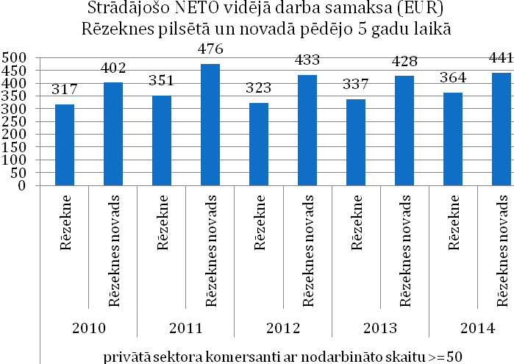

|  |  |
| --- | --- |
| Strādājošo NETO vidējā darba samaksa (EUR) Rēzeknes pilsētā un novadā pēdējo 5 gadu laikā | Average NET wage (EUR) in Rezekne city and Rezekne district during the last 5 years |
| Rēzekne | Rezekne |
| Daugavpils novads | Rezekne district |
| Privātā sektora komersanti ar nodarbināto skaitu >=50 | Private sector merchants with >=50 employees |

*Figure 21: Average NET wage in Rezekne city and Rezekne district*

## Possible operational plan of the industrial territory in the future

|  |  |  |  |  |  |  |
| --- | --- | --- | --- | --- | --- | --- |
| **Zone/type of terri-tory** | **Offer of the local government** | | | | | **Administration** |
| **Lease of land** | **Sale of land** | **Buildings** | **Financial and tax stimuli** | **Non-financial bonuses from the local government** |
| Industrial park (focused on industrial sectors) | Long-term lease of land - maximum duration of the lease contract – 30 years (lease payment depends on improvements of the territory, between 800 and 900 EUR/ha per year, including VAT) | Possible (price determined within evaluation of the land plot by certified evaluator shall be the entry price for auction of the land plot to be organized later and allowing participation of all interested persons) | Currently partially built and partially vacant territory (reconstruc-tion and construction of buildings is up to the private investor) | Reduction of corporate income tax and real estate tax, reduction of VAT and customs duties, reliefs of the labour force taxes (according to Rezekne Special Economic zone Law); exemption of import and export transactions from customs tax and VAT | Infrastructure projects – construction of roads and communications to the object at the local government’s expense, participation in the city’s business development measures: catalogues, exhibitions, forums etc., informative support, assistance in search for specialists | Separate unit – land owned by the local government, managed by the administration of RSEZ |

**Involved parties and their competencies**

|  |  |
| --- | --- |
| **Key involved parties** | **Competencies** |
| State | * Investments in infrastructure (main roads, Daugavpils airport, modernization of education institutions and other) * Financial stimuli (for example, reduction of labour force taxes) |
| Local government and RSEZ | * Provision of land and long-term lease to the private managers of the industrial territory * Real estate tax relief * Construction of public technical infrastructure – roads and communications – to the object * Notification of education institutions on necessity for specialized education and training programmes for the preparation of employees significant for the investors * Calling of education institutions to provide support for the enterprises in training of employees * Support in search for labour force and training of employees * Support in incubation of entrepreneurship * Inclusion of private investors in the city’s business development measures, including catalogues, exhibitions, forums (informative support) |
| Latgale planning region (Latgale Entrepreneurship Centre) | * Support for project management * Calling of the SEA (and other institutions in charge) to provide adult re-training and lifelong education programmes * Support in search for labour force and staff training * Support in search for business partners within the region for establishment of clusters (of specialized enterprises and other involved parties, including support institutions, groups with tight mutual cooperation within a certain territory and sector) * Support for enterprises in establishment of local supply chains * Provision of link with knowledge and technology transfer centres within the region (to be providing advice for development of new technologies and improvement of productivity) in order to increase technological competencies of the enterprises * Support in incubation of entrepreneurship, attraction of entrepreneurship grants and funding of funds |
| Private sector | * Construction of necessary buildings in the industrial zone * Management of the industrial territory and provision of services for other participants thereof * Establishment of electricity, IT infrastructure, water supply and sewerage networks, gas and heating inlets to the objects * Recruitment * Corresponding adjustment of the industrial territory * Incubation of entrepreneurship, attraction of entrepreneurship grants and funding of funds |

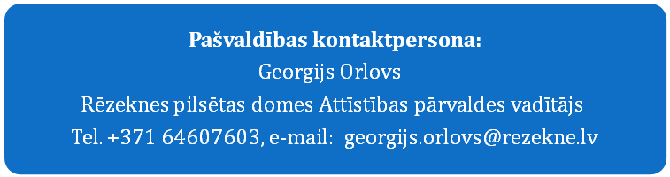

|  |
| --- |
| **Liaison person of the local government:**  Georgijs Orlovs, Head of the Development Department of Rezekne City Council  Phone: +371 64607603, e-mail: georijs.orlovs@rezekne.lv |

## ANNEXES – other information related to the project

### Available technical documentation

* Topographical measurement and topographical plan of the land units in the industrial territory of Northern district of Rezekne city (total area 22.7 ha)
* Orthophotographs of the industrial territory of Northern district at the area of 156 ha (surface relief model) taken by photogrammetric method

Materials of topographical measurement, topographical plan and orthophotographs are available as a separate volume of documents.

### Presentation of description of the industrial zone (ppt)

Presentation (ppt) on Investment project for REZEKNE Northern industrial zone in English and Russian

### Photographs of the industrial zone

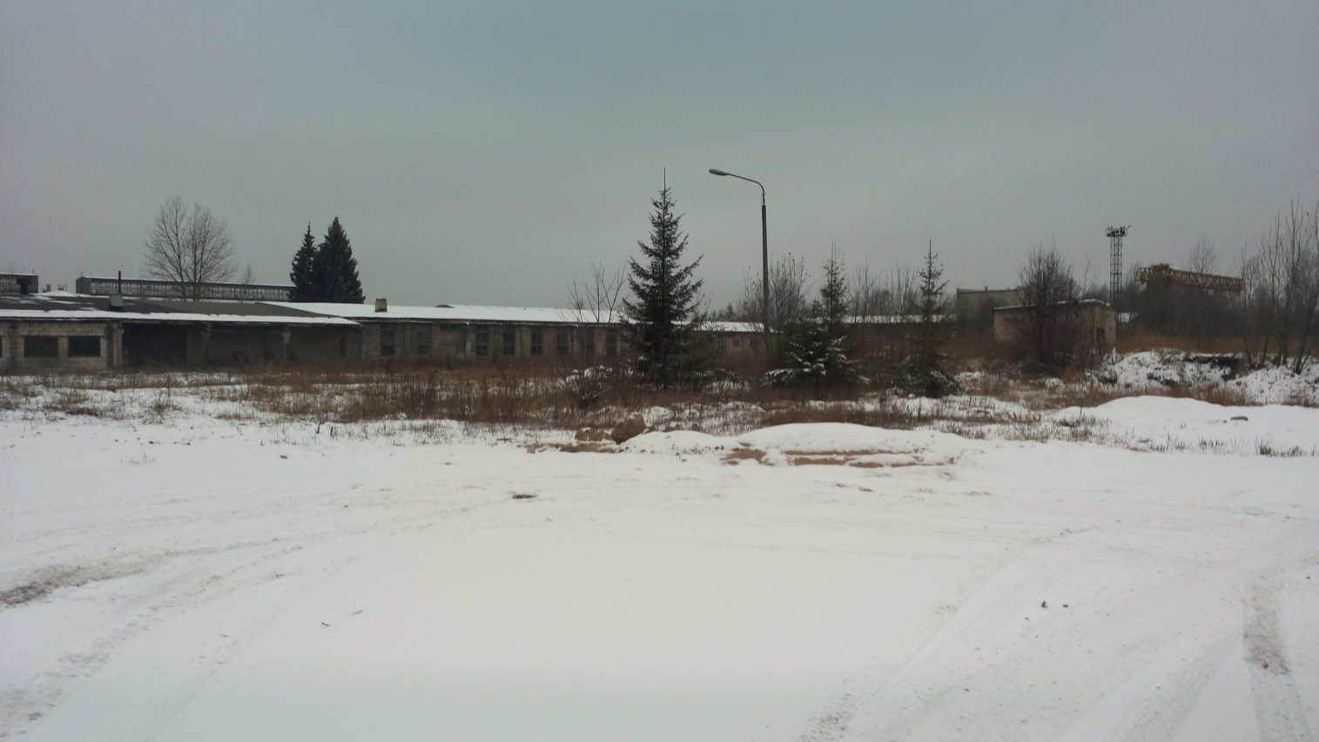

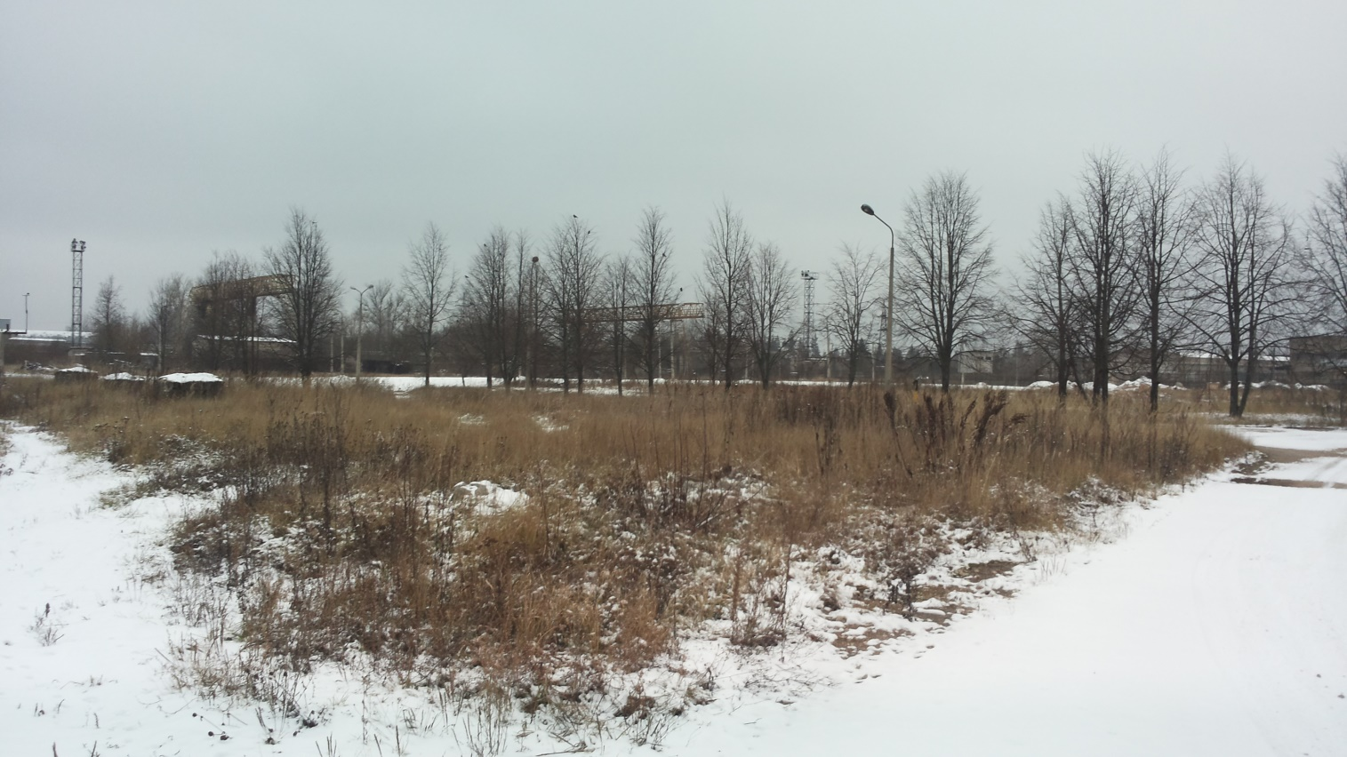

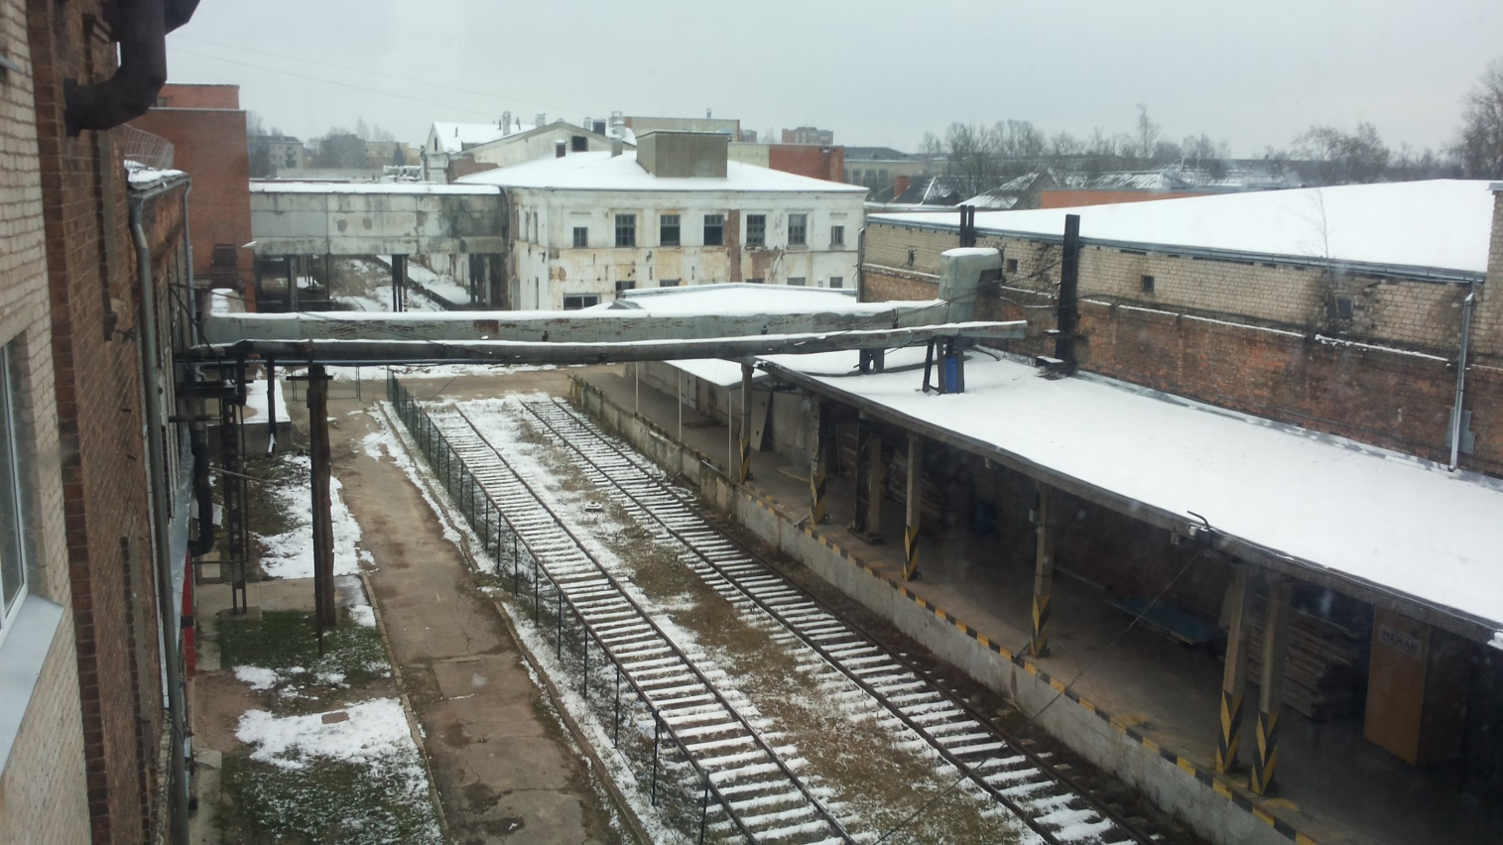

1. Legal entities and natural persons having manufactured products, provided services or employed people during the reference period in the corresponding period of time regardless of whether they were active for the entire reference period or part thereof.
2. Source: “Strategy for Investment Attraction to Urban Areas in LV-LT Cross-border Region” /2014/
3. Varied educational process of persons (aged between 25 and 64) providing person’s development and competitiveness in the labour market.
4. Selected on the basis of comparative advantages of Latgale – sectors including natural resources in Latgale (and Latvia), favourable geopolitical location, labour force skills and traditions in long-term period, competitiveness of educational and research institutions. Additional factor – speed of growth of the perspective sector worldwide, as well as the EU support for the solution of social challenges in separate sector (European Commission communication document “ES 2020”, managing initiative of the strategy “Innovation union”).
5. Packet of investment project within the context of WILLINVEST is an entirety of documents for a successful presentation of the urban territory owned by the local government to the potential investors. This will be the base for further work of the regional and local governments in investment attraction in the specific city territory (industrial zone), until these territories will be completely restored (document will serve at least 10 years after the end of the WILLINVEST project). Packet of investment project must stimulate active direct marketing of these zones (objects) both on the internet and on-the-spot in municipalities, and through the experts taking this information to business exhibitions and forums of investors. These results will stimulate further practice of investment projects and initiatives to satisfy needs of the local municipalities and provide higher economic and social welfare for the residents of Latgale region.
6. *Development of this sector may seem to be endangered in the context of economic sanctions of 2014; however, representatives of the sector concerned do not believe such a situation would last in the long term.*
7. Source: http://www.rsez.lv/lv/nodoklu-atlaides