 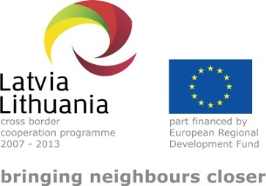 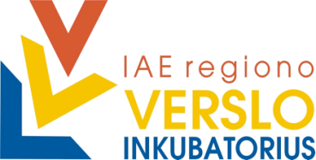 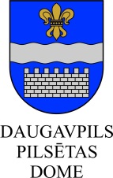

PROJECT

“Strategy for Investment Attraction to Urban Areas

in LV-LT Cross-border Region – WILLINVEST”

(No. LLV-390)

**Description of investment project for  
DAUGAVPILS Northern industrial zone**

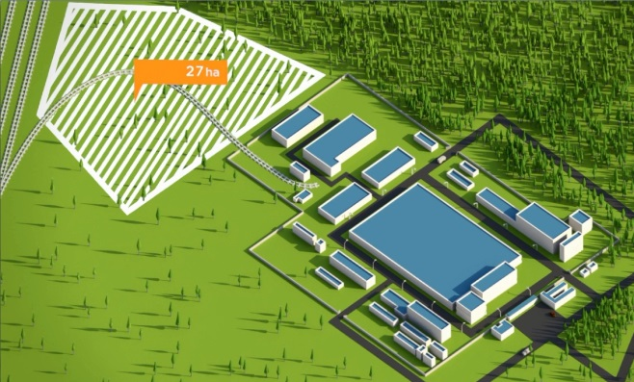

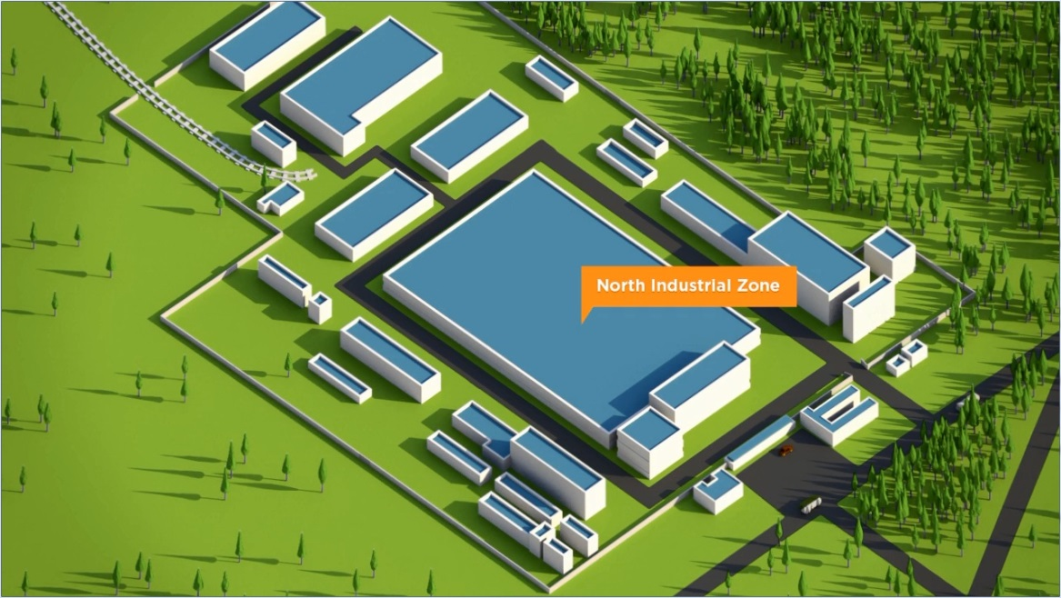

Daugavpils, 2015

**TABLE OF CONTENTS**

1 LATGALE REGION in Latvia 3

Geographical location of the region 4

Transport and logistic infrastructure 5

Residents of the region 6

*Education* 8

*Unemployment and job seekers* 12

Enterprises and non-financial investments 13

Public support to the entrepreneurship 19

2 DAUGAVPILS in the regional context of Latgale 21

3 Description of the investment project for DAUGAVPILS industrial zone 26

3.1 Name of the urban area industrial zone 26

3.2 Location, area, zoning 26

3.3 Property rights 27

3.4 Entrepreneurship sector 27

3.5 General description and goals of the project 27

3.6 Description of the industrial zone 27

3.7 Analysis of investor’s opportunities 29

3.8 List of potential clients and cooperation partners 29

3.9 Summary of investments 30

3.10 Possible operational plan of the industrial territory in the future 33

3.11 ANNEXES – other information related to the project 35

Available technical documentation 35

Presentation of description of the industrial zone (ppt) 35

Photographs of the industrial zone 35

# LATGALE REGION in Latvia

|  |  |  |
| --- | --- | --- |
| **The CURRENT social economical indicators** | | **Indicators in Latgale** |
| Area, km2 | | 14 549 |
| Area in % of the total area of the country | | 22.5 |
| Number of residents, on 01.01.2015 | | 311 058 |
| Rate of the number of residents in % of the total number of residents of Latvia | | 14% |
| Density of residents per 1 km2 (number of people) | | 20 |
| Total GDP in 2012, thousand EUR | | 1 823 870 |
| Total GDP in 2012, ration in % | | 8.3 |
| Total GDP in 2012 (per resident, EUR) | | 6 176 |
| Number of unemployed people on 31 December 2014 | | 23981 |
| Unemployment rate, % of the total number of economically active residents | | 17.8 |
| Approximate volume of potential labour force available in the region | | ~ 20 000 people |
| Proportion of the students of the institutions of vocational education | | 45% (higher than on average in Latvia) |
| Non-financial investments (in reference prices of 2013, million EUR) | | 433.5 |
| Planned revitalization of degraded territories and readjustment thereof for entrepreneurship (ha) up to 2023 | | ~ 125 |
| Economically active statistical units of market sector[1] (in 2013) | | 18160 |
| Sectors with the highest competitiveness[2] | 1. Manufacture of other transport equipment 2. Manufacture of electric equipment 3. Manufacture of machinery and equipment | |

**FUTURE vision of Latgale for 2030**

“Smart Latgale” with 300 000 residents,

characterized by the following words – netting, cooperation and speed.

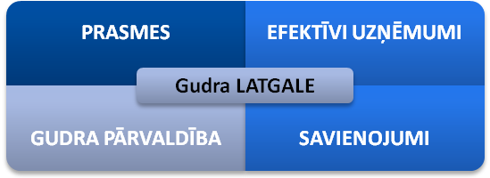

|  |  |
| --- | --- |
| **SKILLS** | **EFFICIENT ENTERPRISES** |
| **Smart LATGALE** | |
| **SMART ADMINISTRATION** | **CONNECTIONS** |

*Figure 1: Four strategic directions or long-term priorities of Latgale strategy 2030.  
Source: Latgale programme 2010 - 2017*

## Geographical location of the region

Acreage of the territory of Latgale is 14 549 km2. Location of the region is characterized by the Eastern border of the EU and the neighbouring regions of Russia, Pskov county and Belarus, Vitebsk county.

Convenient connections of the EU importance roads and railway lines connect the largest cities of Latgale – Daugavpils and Rezekne – with Riga, Pskov, Vilnius, St.Petersburg, Warszawa, Vitebsk, Moscow, as well as interconnected within the region.

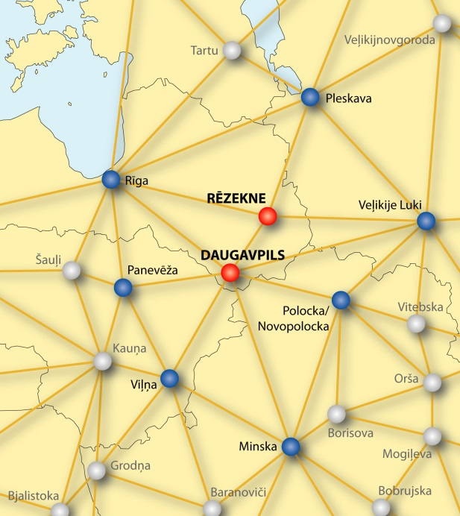*Figure 2:*

*Cities of Latgale region in the international  
network of cities (Data: LLC (SIA) “Grupa 93”)*

Latgale is located in the Eastern part of Latvia and North-Eastern part of the EU, at the same time it is the border region of the EU. Latgale region borders with the Russian Federation in the East, with the Republic of Belarus in South-East and with Lithuania in the South. Eastern border of the EU still functions as a barrier with restricted number of border crossing points and non-constructed customs control offices in the territory of Latvia, as well as strict control of freight and passenger flow. Cross-border economic links are restricted by visa regime with Belarus and Russia.

Three important international transport corridors cross the region providing for Latgale direct connections with the largest centres of the neighbouring countries – Moscow, Vitebsk, Smolensk, Kaunas, Vilnius, Warszawa, Pskov and St.Petersburg. The largest city of Latgale – Daugavpils – serves as a centre of commercial services also for the North-Eastern territory of Lithuania with approximately 150 thousand residents, around the same as in the part of the territory of Latvia.

In Latvia Latgale Planning region borders with Vidzeme Planning region in North-East and with Zemgale Planning region in the West. Latgale has been integrated in the economic network and the service network of Latvia, which is characterized by the region’s large cities’ – Daugavpils and Rezekne – links with Riga. Functional links of Rezekne – Daugavpils – Jekabpils (regional centre of Zemgale) are of significant importance, while in the space of Northern Latgale Balvi has established real functional links with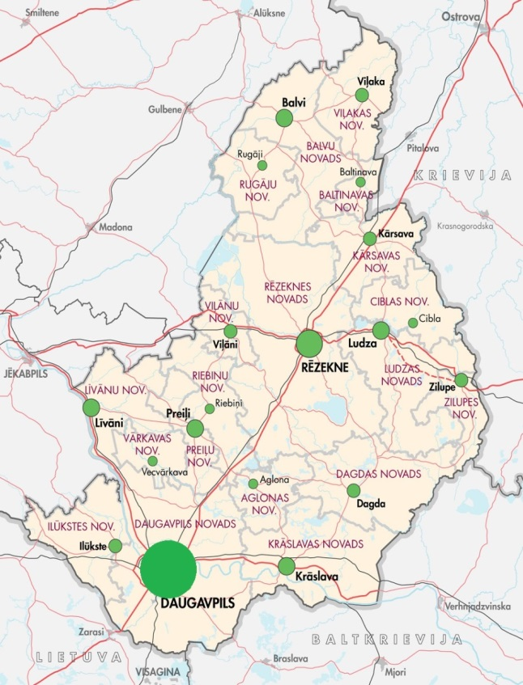 Aluksne and Gulbene in Vidzeme region. Latgale is connected with Vidzeme region towns Madona, Cesis, Gulbene, Aluksne and Valmiera by developed road network.

Territory of Latgale region occupies 22.5% of the entire area of the country. Proportion of residents in the total number of residents nationwide was 14.55% at the beginning of 2014.

*Figure 3:*

*Latgale regional municipal administrative centres*

*(Data: SIA „Grupa 93”)*

## Transport and logistic infrastructure

*Roads*

Latgale is crossed by three roads of national importance and also three roads of international importance:

* A6 Riga-Daugavpils-Kraslava-Border of Belarus (Pāternieki)
* A12 Jekabpils-Rezekne-Ludza-Border of Russia (Terehova), which is a part of the European road network E22 (Holiheda-Ventspils-Riga-Velikije Luki-Moscow-Vladimir-Nizhny Novgorod)
* A13 Border of Russia (Grebneva)-Rezekne-Daugavpils-Border of Lithuania (Medumi), which is a part of the European road network E262 (Kaunas-Ukmerge-Daugavpils-Rezekne-Ostrova).

*Railway traffic*

Latgale region is crossed by several railway lines of international importance:

* Maskava–Zilupe–Rezekne-Krustpils–Jelgava-Ventspils;
* Vitebska-Indra–Daugavpils-Krustpils-Riga;
* St.Petersburg-Karsava-Rezekne-Daugavpils-Eglaine-Klaipeda/Kurcums -Vilnius.

Railway corridors are situated in parallel with the three main roads, thus strengthening the role of Rezekne and Daugavpils as important regional hubs.

*Air traffic*

Daugavpils airport, which is certified as a general aviation aerodrome, is located in the region. Regular flights are operated here by sports, medical aid, military and dusting planes.

Aerodrome in Rezekne is being used for training flights only.

International airports at the closest distance from Latgale region are located in Riga (approximately 250 km from Rezekne and Daugavpils), as well as in Vilnius and Kaunas in Lithuania (approximately 200 km from Daugavpils and over 300 km from Rezekne).

Work on development of design of the regional airport in Daugavpils has been commenced. The airport is located at Naujenes parish, Lociku village, at 1 km distance from the main national road Border of Russia (Grebneva) - Rezekne - Daugavpils - Border of Lithuania (Medumi) (A13), which is a part of the road of European importance E262 Warszawa – St.Petersburg, and 1 km from the main national road Riga - Daugavpils – Kraslava - Border of Belarus (Pāternieki) (A6). The airport is located near the railway line Riga – Daugavpils – Indra. Location by important transport corridors makes the position of Daugavpils airport attractive. Land is the property of municipality. Total amount of the necessary investments is approximately 60 million euro.

Several voluminous researches regarding development opportunities of transport and logistic services in Latgale region have been executed. Conclusions regarding freight flows in Latgale region resulted from the research “Analysis of the potential of Latgale and Vidzeme regions, Pskov and Leningrad counties in the field of transport and logistics. Current trends and development opportunities” were as follows:

* Freight flow from the East to the West mostly moves along railway; from the West to the East – along roads; freight transport through the border of Latvia and Russia mainly consists of transit transport;
* Growing segment of railway transit consists of container transport related to increase of finished products import from the EU and Asia to Russia. This kind of transport will continue developing;
* Mostly finished products produced in the EU and destined for Russia are being transported along roads. There is fully reasonable ground to consider that volume of road transport in the direction from the EU to Russia will grow in short-term and medium-term perspective;
* The current road network in Latgale region allows doubling of the turnover of road transport provided that road surface will be improved and the section Ludza – Terehova will be reconstructed;
* Loading of railway infrastructure allows significant increase of freight flow through the region. Loading of several railway sections in the Eastern – Western corridor accounts for just 50%. Increase of the railway capacity is planned by increase of freight flows;
* Capacity of the main motor roads allows for at least double increase of transport causing no serious problems in Latgale region.

## Residents of the region

311 058 residents were registered in Latgale region at the beginning of 2015. Changes in number of residents from the beginning of 2009 until the beginning of 2014 show approximately 8% decrease of residents of Latgale.

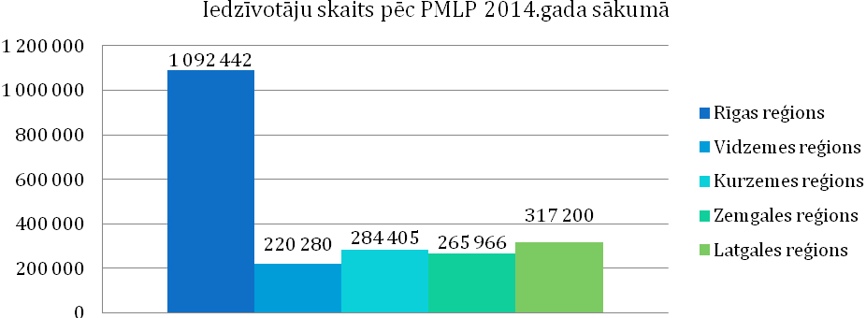

|  |  |
| --- | --- |
| Iedzīvotāju skaits pēc PMLP 2014.gada sākumā | Number of residents according to OCMA at the beginning of 2014 |
| Rīgas reģions | Riga region |
| Vidzemes reģions | Vidzeme region |
| Kurzemes reģions | Kurzeme region |
| Zemgales reģions | Zemgale region |
| Latgales reģions | Latgale region |

*Figure 4: Number of residents in the planning regions at the beginning of 2014*

*(Source: The Office of Citizenship and Migration Affairs)*

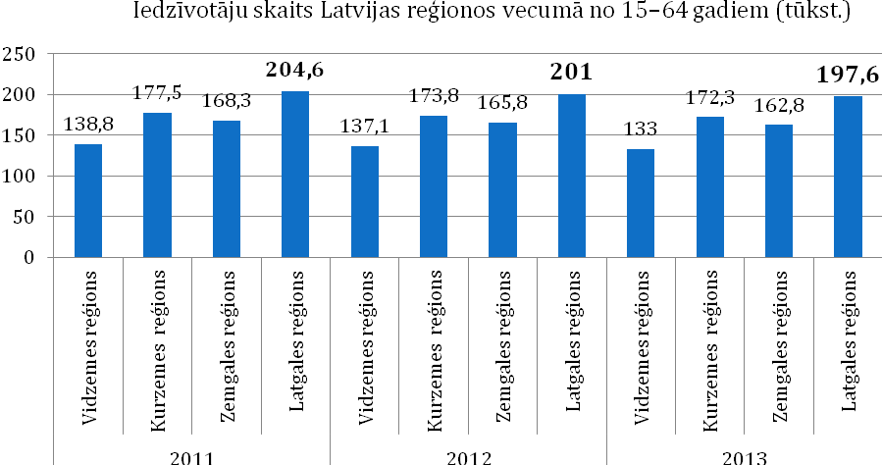

|  |  |
| --- | --- |
| Iedzīvotāju skaits Latvijas reģionos vecumā no 15-64 gadiem | Number of residents in the regions of Latvia, age group 15-64 |
| Vidzemes reģions | Vidzeme region |
| Kurzemes reģions | Kurzeme region |
| Zemgales reģions | Zemgale region |
| Latgales reģions | Latgale region |

*Figure 5: Number of residents in the planning regions 2011 - 2013*

*Source: Central Statistical Bureau of the Republic of Latvia*

### Education

***Secondary and secondary vocational education***

1672 students studied in the 12th grade of general education schools in Latgale region in 2014; they form basis for the studying youth of the region.

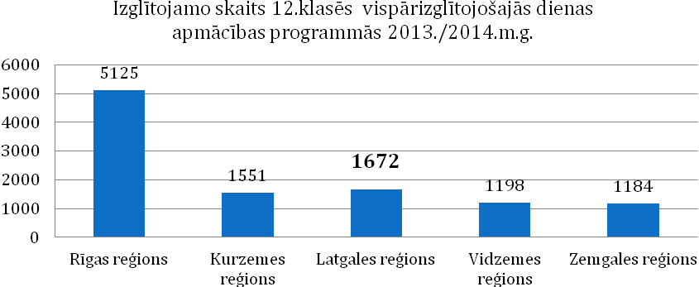

|  |  |
| --- | --- |
| Izglītojamo skaits 12.klasēs vispārizglītojošajās dienas apmācības programmās 2013./2014.m.g. | Number of students in 12th grades of full-time general education programmes in 2013/2014 school year |
| Rīgas reģions | Riga region |
| Vidzemes reģions | Vidzeme region |
| Kurzemes reģions | Kurzeme region |
| Zemgales reģions | Zemgale region |
| Latgales reģions | Latgale region |

*Figure 6: Number of students in 12th grades of full-time general education programmes in 2013/2014 school year*

*Source: Ministry of Education and Science of the Republic of Latvia*

Secondary vocational education can be acquired in the following specialities in Latgale:

* Vocational education programmes in the field of **mechanical engineering and metalworking** are being implemented in Daugavpils State Technical School (metal processor, turner, fitter, locomotive facilities technician, transport car technician, railway track facilities technician and rolling stock fitter).
* Vocational education programmes in the field of **construction** are being implemented in Dagda Vocational Secondary School (finishing work worker), Daugavpils State Technical School (finishing work technician, finishing work worker, bricklayer, tile stove potter, sanitary equipment assembler, road construction technician), Rezekne Technical School (former Eastern Latgale Vocational Secondary School) (finishing work worker, builder of buildings, finishing work technician, woodworker, construction worker), Jaunaglona Vocational Secondary School (builder of log buildings, woodworker, repairer).
* Vocational education programmes in the field of **power industry, electronics and automation** are being implemented in Latgale Transport and communication technical school (electrician), Rezekne Technical School (former Eastern Latgale Vocational Secondary School) (electrician), Daugavpils State Technical School (wireman).
* Vocational education programmes in the field of **machinery sciences** are being implemented in Dagda Vocational Secondary School (motor engineer), Daugavpils Technical School of Construction (car electrician), Jaunaglona Technical School (motor engineer), Daugavpils State Technical School (motor engineer, railway track facilities technician, locomotive facilities technician, transport car technician, railway transport safety technician, railway transport automation, telemechanics and communications technician), Rezekne Technical School (former Eastern Latgale Vocational Secondary School) (motor engineer, assistant motor engineer), Malnava college (motor engineer), Viski Vocational Secondary School (agriculture machinery mechanics).
* Vocational education programmes in the field of **production of foodstuffs** are being implemented in Rezekne Technical School (former Eastern Latgale Vocational Secondary School) (foodstuffproduction technician).
* Vocational education programmes in the field of **textile production** are being implemented in Rezekne Technical School (former Eastern Latgale Vocational Secondary School) (producer of sewn products, tailor), Daugavpils Vocational Secondary School No. 1 (assistant sewer, sewer, tailor), in Dagda Vocational Secondary School (tailor).
* Vocational education programmes in the field of **tourism and recreation organization and Hotel and restaurant services** are being implemented in Bebrene Vocational Secondary School (hotel service specialist), Dagda Vocational Secondary School (catering service specialist, cook assistant), Rezekne Technical School (former Eastern Latgale Vocational Secondary School) (catering service specialist, hospitality service specialist, cook), Viski Vocational Secondary School (catering service specialist), Daugavpils Trade Vocational Secondary School (cook, confectioner, restaurant service specialist), Preili Vocational Secondary School (cook).
* Vocational education programmes in the field of **wood processing** are being implemented in Daugavpils Vocational Secondary School No. 1 (assistant carpenter), Daugavpils State Technical School (cabinet-maker, carpenter) and Rezekne Technical School (former Eastern Latgale Vocational Secondary School) (cabinet-maker).
* Vocational education programmes in the field of **agricultural specialities** are being implemented in Malnava college (rural property manager), Viski Vocational Secondary School (rural property manager, agricultural machinery mechanic), Technical School (former Eastern Latgale Vocational Secondary School) (pisciculturist), Bebrene Vocational Secondary School (assistant veterinarian).

***Higher education***

Currently two regional institutions of higher education offer higher education in Latgale – Daugavpils University, Rezekne University of Applied Sciences – and branches of 13 other institutions of higher education of Latvia located in Daugavpils, Rezekne and Balvi.

**Daugavpils University** is the second largest classic type state university in Latvia. It keeps its development as an important scientific research centre in Latgale. Daugavpils University offers studies in 5 faculties:

* [The Faculty of Natural Sciences and Mathematics](http://www.du.lv/en/about_university/faculties/dmf)
* [The Faculty of Humanities](http://www.du.lv/en/about_university/faculties/hf)
* [The Faculty of Education and Management](http://www.du.lv/en/about_university/faculties/ivf)
* [The Faculty of Music and Arts](http://www.du.lv/en/about_university/faculties/mmf)
* [The Faculty of Social Sciences](http://www.du.lv/en/about_university/faculties/szf)

Daugavpils University implements measures to attract students from Latgale region, as well as from other regions of Latvia and foreign students. In order to satisfy the labour market demand in Latgale region, Daugavpils University expands opportunities of studies in various thematic fields and purposefully develops demanded programmes: in natural sciences and engineering sciences (*Environmental science, Environmental planning, Computer sciences, Physiotherapy, Information technologies, Solid State Physics and other)*, in social sciences by highlighting the importance of entrepreneurship in the development of national economy and regional aspects (*Law, Law sciences,* [*Economics*](http://www.du.lv/lv/studijas/programmas/bakalaurs/ekonomika)*,* [*Carrier advisor and specialist of youth affairs*](http://www.du.lv/lv/studijas/programmas/profesionalais_magistrs/karjeras_konsultants_un_jaunatnes_lietu_specialists)*, Management sciences,* [*Psychology (social psychology)*](http://www.du.lv/lv/studijas/programmas/magistrs/psihologija)and other), in humanities by highlighting the international social economic cooperation (*Easter Europe Cultural and Business Connections, Interpreter (translator)* and other) and in art (*Design, Art management* and other).

Development of new inter-disciplinary study programmes are also in progress for preparation of more diversified specialists able to adapt better to the changeable social economic environment and labour market not only in Latvia, but also nationwide.

Several scientific institutes and centres are operating in Daugavpils University performing scientific research activities in various fields. *Institute of humanitarian and social sciences* has been established since 2014 by combining several former institutes and centres – Institute for Sustainable Education, Institute of Comparativistics, Social Research Institute and Latgale Research Institute. *Institute of Life Sciences and technologies* was established combining Institute of Ecology, Institute of Systematic Biology, G.Liberts Centre of Innovative microscopy and Mathematical Research Centre. Besides, *Oral History Centre* and *Institute of Art Sciences* operate in Daugavpils University.

**Rezekne University of Applied Sciences** is a state institution of higher education established on the basis of branches of the University of Latvia and Riga Technical University. Rezekne University of Applied Sciences implements study programmes, as well as is active in the field of science, research and artistic creative work. There are four faculties in Rezekne University of Applied Sciences:

* **Faculty of Education and Design**,
* **Faculty of Humanities and Law**,
* **Faculty of Engineering**,
* **Faculty of** Economics and Management.

Task of Rezekne University of Applied Sciences – improvement of proportion of the residents with higher education in Rezekne city and Latgale region, as well as attraction of secondary schools graduates to studies and – after the studies are finished – to work in Latgale region.

Rezekne University of Applied Sciences has established tight cooperation with local governments. RA Convention consists of heads of local governments and entrepreneurs from Latgale region. Together with local governments RA has developed projects of national importance, for example, project of Rezekne Special Economic Zone.

Rezekne University of Applied Sciences provides further education opportunities by offering on average 20 – 30 courses and programmes of professional improvement and further education annually.

Four scientific institutes for the development of scientific activity have been established in Rezekne University of Applied Sciences:

- Latgale sustainable development research institute (LIAPI),

- Latgale national economy research institute (LTPI),

- Personality socialization research institute (PSPI),

- RA Institute of Letonica (RALI).

Besides the two previously mentioned institutions of higher education based within the region studies in Latgale are provided by a number of branches of the institutions of higher education established by legal entities and natural persons from the capital (Baltic International Academy, The University College of Economics and Culture, Information Systems Management Institute, The Art Academy of Latvia, University of Latvia, Customs college, Higher School of Psychology, Riga Aeronautical Institute, Riga Technical University, Higher School of Social Technologies, Transport and Telecommunication Institute, Higher School of Management and Social Work “Attīstība” [“Development”], State Border Guard College).

Large part of the study programmes is suitable also for the specific requirements of the labour market. For example, Latgale branch of Transport and Telecommunication Institute offers to residents of the region higher vocational education in the following study programmes: “*Transport and business logistics”* and *“Transport entrepreneurship management”*, as well as bachelor degree in study programme *“Transport commercial exploitation”*. A new programme has also been developed, which, upon studying in Daugavpils for the entire period of studies provides opportunity to acquire academic degree *“Bachelor of Engineering Sciences in Machine Science”*. Speciality of this programme called *“Overground transport exploitation”* has been prepared especially for Latgale branch. The programme has been developed taking into consideration the regional specificities and recommendations of the specialists working in the sector of transport companies. This is the basis of the education of engineer. Over 65% of the load of studies have been assigned for the acquirement of classical subjects of engineering sciences and approximately 35% - for the subjects related to management, economics, languages and other. The entire process of studies takes place at TSI Latgale branch, furthermore, material facilities of Latgale transport and telecommunications technical school and “Daugavpils Locomotive Repair Plant” and modern computer technologies are being used. Traineeship takes place at “Latvijas Dzelzceļš” and “Daugavpils autobusu parks”, as well as other transport enterprises of Latgales region.

***Lifelong education***

In comparison with other regions of Latvia higher activity in the field of lifelong education (adult education) [3] can be observed in Latgale. In 2011 the highest percentage of adults (excluding Riga and Greater Riga region) were involved in acquirement of both formal and informal education. Although no statistical data regarding the very recent years are available, situation could be similar. It has been observed that women are more active than men in the field of lifelong education.

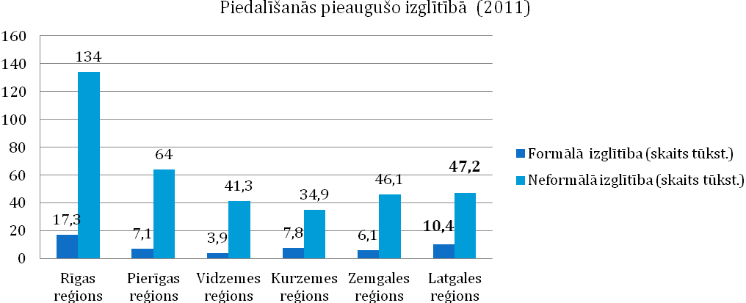

|  |  |
| --- | --- |
| Piedalīšanās pieaugušo izglītībā (2011) | Participation in adult education (2011) |
| Rīgas reģions | Riga region |
| Pierīgas reģions | Greater Riga region |
| Vidzemes reģions | Vidzeme region |
| Kurzemes reģions | Kurzeme region |
| Zemgales reģions | Zemgale region |
| Latgales reģions | Latgale region |

*Figure 7:* *Participation in adult education (2011)*

*Source: Central Statistical Bureau of the Republic of Latvia*

### Unemployment and job seekers

Rate of the registered unemployment was 8.5% nationwide on 31 December 2014 (proportion of the registered unemployed persons within the total amount of economically active residents). The highest unemployment level was just in Latgale region (17.8%), where the total number of unemployed persons was 23981.

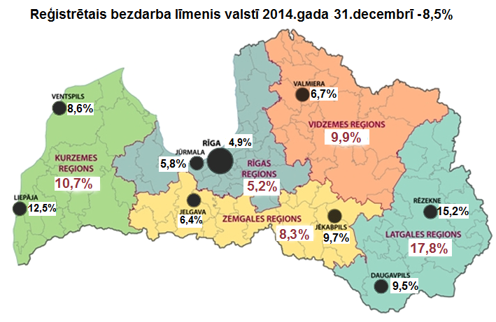

**Rate of the registered unemployment nationwide on 31 December 2014 - 8.5%***Figure 8: Rate of the registered unemployment nationwide**and in regions in December of 2014*

*(Source: Data of SEA)*

According to the data provided by the Central Statistical Bureau of the Republic of Latvia there were approximately 2300 active job seekers with higher education, 7900 job seekers with vocational education or vocational secondary education and approximately 8000 job seekers with general higher education.

Taking into consideration the available re-training measures for unemployed persons the potential labour force of approximately 20 000 is available in the region.

## Enterprises and non-financial investments

Entrepreneurship environment of Latgale planning region is not much different from other regions, however, such individualities of the region as lower value added of the finished products, lower purchasing capacity of residents and higher rate of self-employed persons should be noted.

There were 48 economically active statistical units of market sector per one thousand residents in Latgale region in 2013.

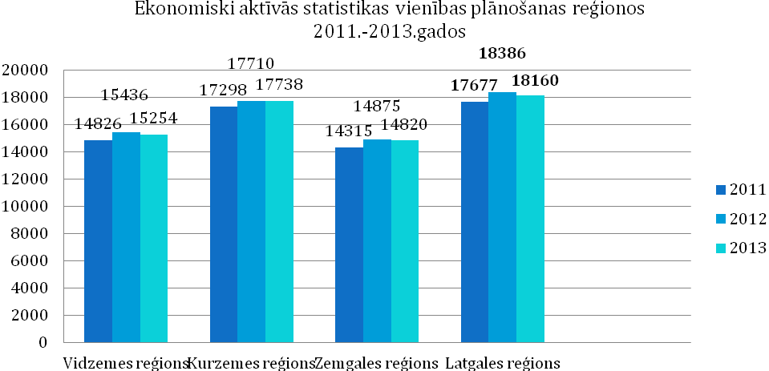

|  |  |
| --- | --- |
| Ekonomiski aktīvās statistikas vienības plānošanas reģionos 2011-2013 | Economically active statistical units in the planning regions 2011-2013 |
| Vidzemes reģions | Vidzeme region |
| Kurzemes reģions | Kurzeme region |
| Zemgales reģions | Zemgale region |
| Latgales reģions | Latgale region |

*Figure 9: Statistical units of market sector* *(self-employed persons, individual merchants, commercial companies, farms and fishing enterprises) Source: Central Statistical Bureau of the Republic of Latvia*

In comparison with other regions self-employed persons accounted for the highest rate of the economically active statistical units of market sector in Latgale region in 2013 significantly exceeding the average rate of Latvia (34.0%). This indicator could show the activity of the residents of Latgale region and their wish to improve their life conditions, as well as this is a way to create job for himself/herself, since the unemployment rate in Latgale is currently the highest nationwide.

There are several enterprises working in Latgale region and producing not only for internal market, but also successfully exporting their products, including LLC (SIA) “Intergaz”, LLC (SIA) “Axon cable”, LLC (SIA) “Zieglera mašīnbūve”, JSC (AS) “Preiļu siers”, LLC (SIA) “Zilā lagūna”, LLC (SIA) “Magistr”, LLC (SIA) “Belmast”, JSC (AS) “Daugavpils lokomotīvju remonta rūpnīca”, LLC (SIA) “Nexis Fibers”, LLC (SIA) “STARS MET”, LLC (SIA) “Z-Light”, LLC (SIA) “Līvānu kūdras fabrika”, LLC (SIA) “Nemo” and other enterprises. For several years a number of enterprises registered in Latgale region have also been among the 100 largest exporters of Latvia. JSC (AS) “Preiļu siers” located in Latgale region was awarded in TOP 500 nomination “TOP regional enterprise” in 2014.

According to the data provided by the Central Statistical Bureau of the Republic of Latvia non-financial investments in Latgale region reached 433.5 million euro in 2013 showing 27.41 million euro growth in comparison with 2008. This indicates on the economical potential of Latgale, as well as necessity to continue additional state-level support for the improvements of the region.

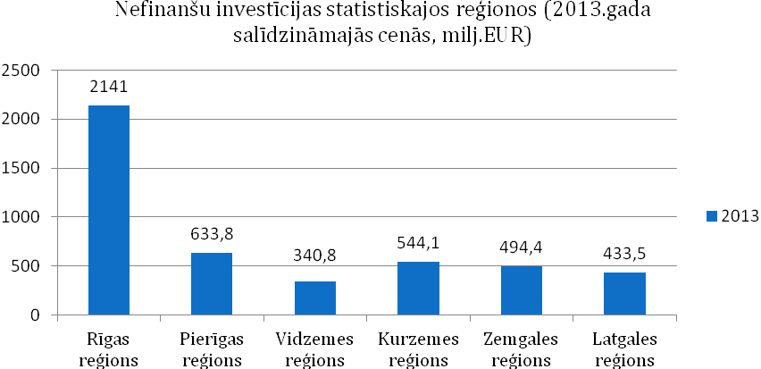

|  |  |
| --- | --- |
| Nefinanšu investīcijas statistiskajos reģionos (2013.gada salīdzināmajās cenās, milj. EUR) | Non-financial investments in the statistical regions (in reference prices of 2013, million EUR) |
| Rīgas reģions | Riga region |
| Pierīgas reģions | Greater Riga region |
| Vidzemes reģions | Vidzeme region |
| Kurzemes reģions | Kurzeme region |
| Zemgales reģions | Zemgale region |
| Latgales reģions | Latgale region |

*Figure 10: Non-financial investments in the statistical regions (in reference prices of 2013, million EUR)*

*Source: Central Statistical Bureau of the Republic of Latvia*

According to the information from Lursoft data base, so far manufacture and wholesale have been the most attractive sectors for the direct foreign investments. Manufacture of other vehicles sector has attracted 13.27% of all direct foreign investments in Latgale planning region (EUR 10 457 642.53), manufacture of chemical products and goods– 6.9%, wholesale – 5.2% (EUR 4 108 499.71), while manufacture of wood products – 5.0% (EUR 3 955 435.60).

The most significant clusters in Latgale region (proportion within the region in comparison with the proportion nationwide by the number of employed persons):

* manufacture of equipment and electric equipment;
* manufacture of other vehicles.

Largest investment flows arrive to Latgale planning region from neighbouring countries of Latvia – Russia and Estonia. Investors from Russia form 43% of the total number of investors, while investors from Estonia – 16% of the total number of investors. The following highest number of investors in Latgale planning region is from Germany, Switzerland, Lithuania and Denmark. Investors from these countries form more than 23% of the total number of investors within the region.

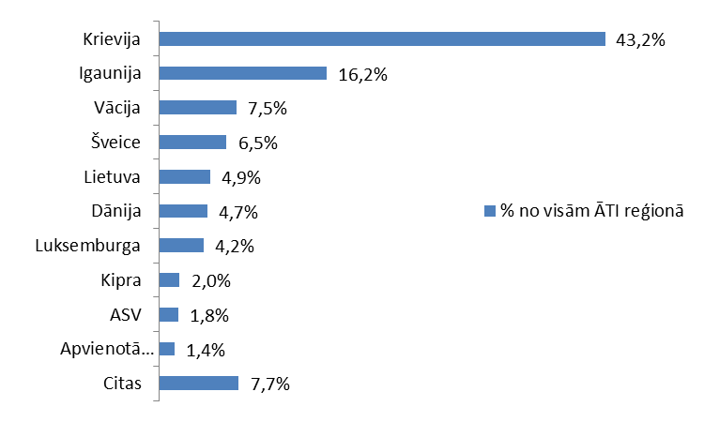

|  |  |
| --- | --- |
| Krievija | Russia |
| Igaunija | Estonia |
| Vācija | Germany |
| Šveice | Switzerland |
| Lietuva | Lithuania |
| Dānija | Denmark |
| Luksemburga | Luxembourg |
| Kipra | Cyprus |
| ASV | USA |
| Apvienotā Karaliste | United Kingdom |
| Citas | Other |
| % no visām ĀTI reģionā | % of all direct foreign investments in the region |

*Figure 11: Distribution of investors by countries, 1994-2014 (Source: Lursoft)*

|  |  |  |
| --- | --- | --- |
| **Positive advantages for investments in Latgale region** | * Location in the single EU market and by the EU border * Availability of qualified labour force in sufficient numbers * Foreign language skills of residents (more than 90% residents of Latgale have a command of at least one foreign language) * Multi-national, tolerant society, multi-language, multi-cultural environment * Availability of the EU co-financing for the local governments for the adjustment of territories, construction of buildings * Corporate income tax nationwide (15%) * Lower labour force costs than on average in the EU * Good connections with Russia and Belarus * Comparatively good road coverage (including the highest proportion of roads with black surface nationwide among regions – 50.2%, however, with variable quality) * Second highest proportion of labour force with secondary education nationwide among regions – 57.9% * Higher concentration of enterprises in sectors of manufacture of equipment, electric equipment and other vehicles than in other regions of Latvia * Access to natural resources - turf, sapropel, wood * Developed logistics allowing attraction of partners in the EU and Russian markets * Rezekne Special Economic Zone – favourable environment for investments and the development of entrepreneurship * Developed capacity of projects in municipalities of cities of national and regional importance * Significant investments in the education infrastructure in recent years (investments in both the institutions of vocational education and the institutions of higher education in Latgale region) * Wide coverage of internet and high internet speed | |
| Perspective sectors[4]  *(Source: Investment and Development Agency of Latvia, “Strategy for Investment Attraction to Urban Areas in LV-LT Cross-border Region” and “Programme of Latgale 2010 – 2017”)* | | * Wood processing and manufacture of wood products * Metalworking and mechanical engineering * Transport and logistics * Information technologies * Food industry * Life sciences * Healthcare * Green technologies * Manufacture of equipment, manufacture of transport and electric equipment * Manufacture of textiles and clothing |

**Cross-border cooperation opportunities**

Taking into consideration proximity of the border additional strengthening of cooperation between the existing institutions in Latgale and Utena/Ignalinas county in Lithuania is possible (for example, between Latgale planning region and Ignalinas nuclear power station region business incubator), as well as between the enterprises located in the borderland. The existing cooperation links between the enterprises may be identified and possible cooperation options in manufacture sectors in the future may be assessed (for example, identification of sectors, where the region exports components of certain product and assessment of opportunities regarding manufacture of other ingredients of the product in the region concerned; or specialist exchange and labour force rent service opportunities).



|  |
| --- |
| **Latgale-Ignalinas nuclear power station (Visaginas) region investment attraction centres*:**  - Industrial park  - Vocational education institutions  - Institutions of higher educations  - Knowledge transfer centres  **Complementary manufacture centres**  - Logistic park  - Vocational education institution  * In Visaginas  Manufacture of wood products  Production of foodstuffs  Mechanical engineering and manufacture of equipment  Power industry services and products  Manufacture of textiles and clothing  Manufacture of metal and metal products  Manufacture of electric equipment |

*Figure 12: Concept map for creation of sinergies in Latgale-Ignalinas nuclear power station (Visaginas) cross-border region*

*Source: “Strategy for Investment Attraction to Urban Areas in LV-LT Cross-border Region”*

## 

## Public support to the entrepreneurship

In order to promote settlement and development of the municipal infrastructure (including entrepreneurship territories) it is planned to commence a new EU fund activity in 2015 including the Specific support goal (SAM) 5.6.2 “Investments in revitalization of degraded territory in Latgale planning region and Aluksne district municipalities”. It is foreseeable that the investment promotion projects will mobilize for entrepreneurship all the current resources of Latgale – enterprises, municipalities and people.

In 2015-2023 local governments of Latgale region plans to invest all together in Latgale region more than 52 million euro for the settlement and revitalization of degraded territories significant for entrepreneurship, including dismantling of buildings, improvement of the existing premises, improvement of squares, aerodromes and industrial territories, creation and/or adjustment of new industrial territories (land areas, buildings and premises), establishment of new engineering communications and connections, reconstruction of streets, roads and bridges.

By using local natural conditions, the EU borderland, the developed logistics and qualified human resources these municipal projects will reduce the negative trends as much as possible, follow and integrate in the development processes of Latvia and the European Union.

There are several national level business and entrepreneurship support institutions operating in Latgale region.

Latvian Chamber of Commerce and Industry and Employers’ Confederation of Latvia have branches in Rezekne and Daugavpils, as well as business support institutions have been established in municipalities (business information or support centres – as separate structural units or municipal specialists, as well as mutual or tripartite advisory councils).

**Business incubators and technology transfer points –** operate to promote establishment and development of new, viable and competitive merchants in Latgale region providing environment required for commercial activity and advisory services.

**Innovation centre of Rezekne University of Applied Sciences** – supports establishment of new, innovative enterprises and provides initial support for start-up. Commercial companies can receive the following services in the Innovation centre of Rezekne University of Applied Sciences:

* Infrastructure services – equipped office premises (furniture, internet, phone, meeting room, kitchen and toilet facilities). Office premises with 18 m2 and 36 m2 area are available;
* Unified services of secretariat and office (fax, copying, processing of incoming and outgoing correspondence and other services);
* Entrepreneurship support services – registration of commercial company, accounting services, drawing up of legal documents, marketing consultations, drawing up of business plans, attraction of the EU structural funds;
* Technological services – designing and development of prototypes of new products and the first experimental models.

**Līvāni Engineering and Innovation Centre (LIIC)** – provides support for the existing town and district enterprises and promotes creation of new ideas and products, as well as establishment and development of new, viable and competitive enterprises in Latgale region. LIIC provides environment necessary for entrepreneurship (rent of premises and equipment, office and other services) and advisory services on matters related to start-up and development of entrepreneurship. LIIC also organizes measures for the increase of youth’s interest and understanding about entrepreneurship on regular basis.

**Technology transfer contact point of Daugavpils University** – goal of its operation is initiating, support and promotion of transfer of knowledge and technologies. This contact point offers:

* informative, methodological and scientific support for the technology transfer process;
* informative support: publications, conferences, exhibitions;
* intellectual property protection services (search for analogues and prototypes, preparation and submission of patent applications);
* promotion of highly technological enterprises and organizations in local and international market;
* measures related to technologies’ export, realization, including conducting of negotiations, conclusion of contracts.

**Environmental technology transfer contact point of Rezekne University of Applied Sciences** is a structural unit of the Sustainable development research institute of Faculty of Engineering of Rezekne University of Applied Sciences providing commercialization of innovative activities in the field of environmental technologies, which promotes implementation of the up-to-date scientific, technical, social or other ideas, elaborations and technologies in a product or service, which is competitive and demanded in the market.

# DAUGAVPILS in the regional context of Latgale

Daugavpils is the second largest industrial centre in Latvia next to the capital Riga and a significant centre of social economic development in the Baltic States. Daugavpils is the largest and the most significant city in the Eastern part of the Baltic States, significant cross-border industrial, transport, entrepreneurship, service, education, culture and tourism centre. Daugavpils is the Eastern gate of the European Union.

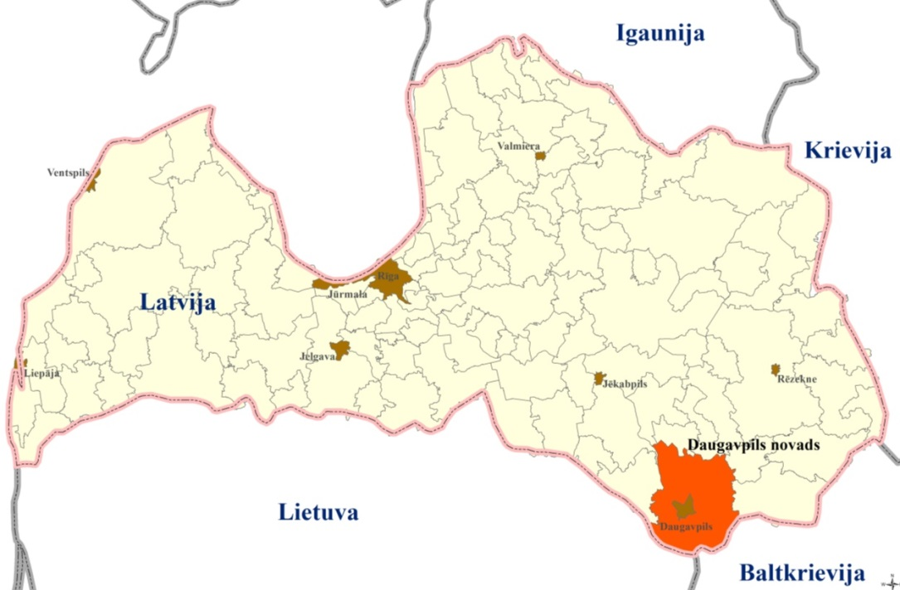

*Figure 13: Location of Daugavpils within Latvia and the region*

Daugavpils city has a number of strategic advantages and wide influence area.

|  |  |
| --- | --- |
| ***Daugavpils and its influence area (2013)***  Distance to Riga | 229 km |
| Distance to the nearest national importance development centre | 90 km |
| Distance to the nearest regional importance development centre | 43 km |
| The nearest national importance development centre | Daugavpils |
| The nearest regional importance development centre | Kraslava, Preili |
| Districts within the influence area | Ilukste, Daugavpils, as well as Konstantinova, Asune, Dagda, Svarinu, Berzinu and Kepova parishes in Dagda district |
| Number of residents in the development centre on 01.01.2015 (data of OCMA) | 96 792 |
| Number of residents in the influence area of the development centre (including the centre) | 141 000 |
| Area of the development centre | 73 km2 |
| Area of the influence area of the development centre | 3063 km2 |

City is with very **favourable geographical location**,

* proximity of border of three countries:

• distance to the border of Lithuania – 25 km,

• distance to the border of Belarus – 35 km,

• distance to the border of Russia – 120 km;

* developed city infrastructure;
* high concentration of educational institutions;
* multi-national environment and heritage;
* natural resources.

Daugavpils is a **significant transport hub in Latvia**. Five railway lines and many roads of strategic importance cross Daugavpils. It is easily accessible from Lithuania, Russia and the border of Belarus.

Distance between Daugavpils city and other cities *(Source: Calculations of Google maps, 2013)*

|  |  |  |
| --- | --- | --- |
| **Name of the city** | **Approximate distance to Daugavpils (km)** | **Approximate duration of ride in the car** |
| Riga | 229 | 3 hours 27 minutes |
| Pskov | 263 | 3 hours 37 minutes |
| Novopolotsk | 168 | 2 hours 55 minutes |
| Vilnius | 172 | 2 hours 33 minutes |
| Verhnedvinsk | 108 | 1 hours 47 minutes |
| Rezekne | 91.3 | 1 hours 24 minutes |
| Jekabpils | 91 | 1 hours 22 minutes |
| Braslava | 47.1 | 57 minutes |
| Livani | 62.4 | 56 minutes |
| Preili | 55.8 | 53 minutes |
| Kraslava | 45.4 | 46 minutes |
| Zarasi | 27 | 31 minutes |



*Figure 14: Interaction zone of functional links of Daugavpils city*

*(Source: Daugavpils city development programme 2014 – 2020)*

Here is the **Education centre of the Eastern Latvia** providing opportunity for youth to acquire education in several institutions of higher and vocational education.

Representatives of more than 20 nationalities call Daugavpils their home.

11 national societies are active in the city.

The city is proud of its **heritage**: Daugavpils fortress with Mark Rotko Art Centre, Baznickalns (Church hill) and the historical city centre with the first pedestrian street in Latvia. Daugavpils theatre, Latgale zoo, Daugavpils Clay Art Centre, multi-functional sports complex, ice hall and speedway competition gives joy to the residents and guests of the city offering active and attractive recreation.

The city is located on both banks of River Daugava. Treasure of the city consists of **natural resources** - forests, lakes, parks and squares. Historically Daugavpils has developed as industrial city with balanced multi-sector economics.

**Most significant industrial sectors** – manufacture of finished metal products, manufacture and repair of railway locomotives and rolling stock, production of foodstuffs and beverages. Manufacture of competitive products is based on modernisation of manufacture equipment and introduction of new, innovative technologies. In general there are approximately 80 companies in the industrial sector, and 50 of them export their products. Employment and welfare of residents is provided by successful operation of small and medium-size enterprises. The city is opened for investments, and this is confirmed by the support of local government for modernization of infrastructure and stimulation of entrepreneurship.

Taking into consideration the fact that Daugavpils historically been developed as industrial centre, there are several industrial territories within the city, which have been in the process of restructurization during the last 20 years, when the large production units were replaced by medium level enterprises with modern technologies.

Economic specialization of Daugavpils city has been determined on the basis of analysis of the current situation, as well as by assessing the profile of economics of Latgale planning region. **Traditional entrepreneurship lines**, which are the most developed in Daugavpils, are: processing industry, especially – manufacturing of metal products and mechanical engineering, production of foodstuffs, manufacturing of textiles un optical cable joints, trade. Majority of these kinds of entrepreneurship is with high value added, which means that economics of Daugavpils city has already been well developed. Further development of traditional kinds of entrepreneurship will facilitate competitiveness of the city in the global market.

Taking into consideration that proportion of manufacture within the gross domestic product decreases in Latvia and Europe, while the proportion of services increases reaching the ratio of approximately 30% : 70%, one of the perspectives of Daugavpils city is increase of the proportion of services, thus increasing proportion of sectors with high value added.

Resources available within the city consist of wide industrial zones, forest territories, wide technical infrastructure, wide hydrographical network, wide housing fund, as well as the existing enterprises and human resources. The insignificant distance to the borders of foreign countries – Lithuania, Belarus and Russia is additional advantage. Significant advantage is also the wide language knowledge of residents facilitating the cooperation with residents and enterprises of the neighbouring countries.

**Strategic goals of future development set by Daugavpils city** are concentrated on the development of knowledge economics and the development of products and services with high value added.

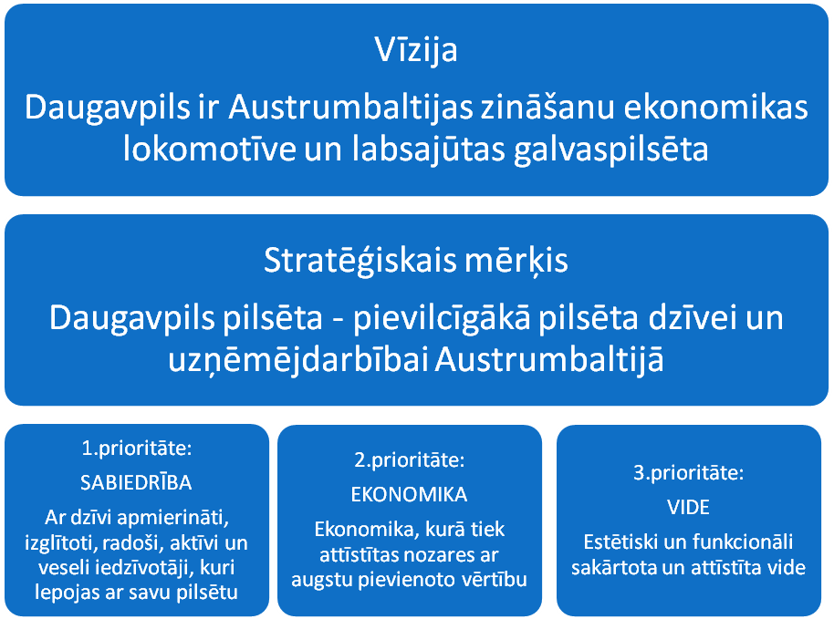

|  |  |  |
| --- | --- | --- |
| Vision  Daugavpils is the locomotive of knowledge economics and feeling of comfort of the Eastern part of the Baltic States | | |
| Strategic goal  Daugavpils city – the most attractive city for life and entrepreneurship in the Eastern part of the Baltic States | | |
| Priority 1:  SOCIETY  Satisfied-with-life, educated, creative, active and healthy residents, how are proud of their city | Priority 2:  ECONOMICS  Economics involving development of the sectors with high value added | Priority 3:  ENVIRONMENT  Aesthetically and functionally settled and developed environment |

*Figure 15: Future development vision and strategic priorities of Daugavpils city*

*Source: “Daugavpils city development programme 2014–2020”*

Perspective recommended new lines of entrepreneurship in Daugavpils:

* transit and logistic services;
* education and export thereof;
* provision of IT services;
* provision of healthcare services and export thereof;
* entertainment, recreation activity and tourism.

Development of Daugavpils city will also affect favourably the development of the entire Latgale region, as well as the adjacent Panevezys region in Lithuania thus developing the market of Baltic States and promoting cooperation between various enterprises within the region.

*More information about the city: www.daugavpils.lv*

*“Daugavpils city development programme 2014–2020”*

# Description of the investment project for DAUGAVPILS industrial zone [5]

## Name of the urban area industrial zone

**Northern industrial zone in Daugavpils**

## Location, area, zoning

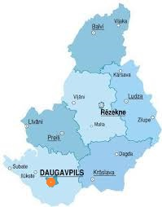 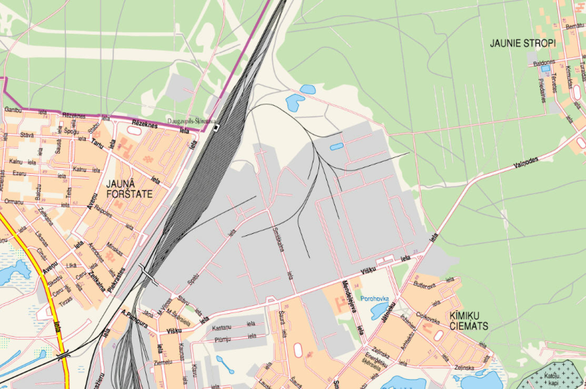

*Figure 16: Daugavpils city in Latgale Figure 17: Northern industrial zone in Daugavpils*

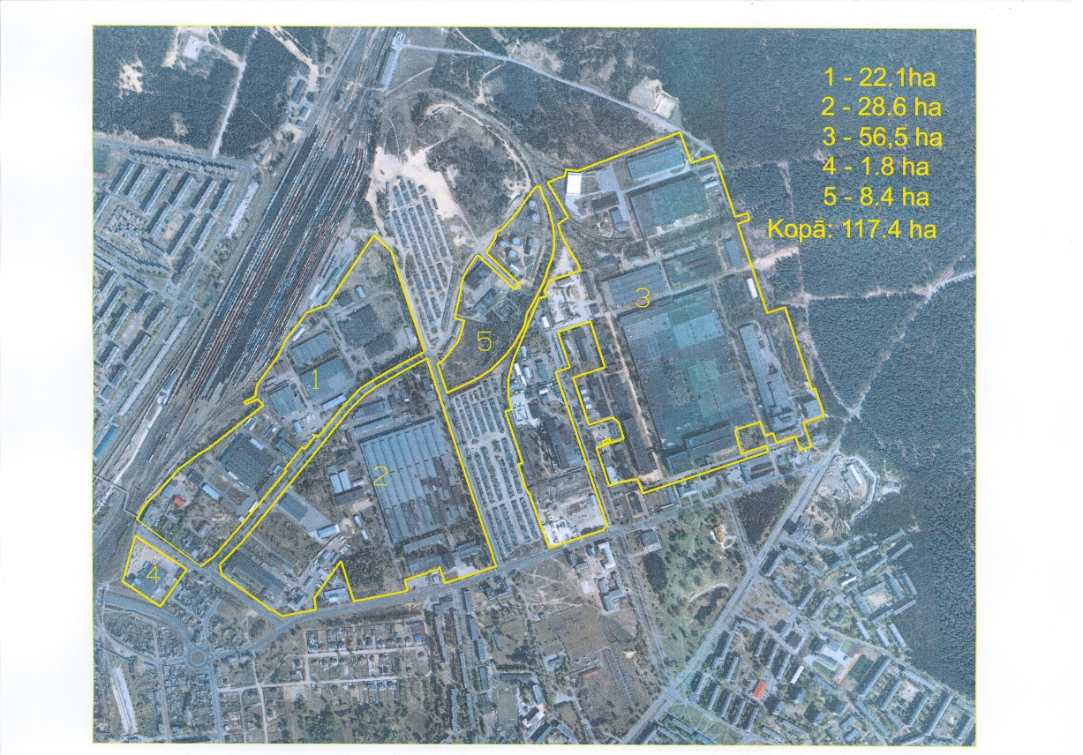 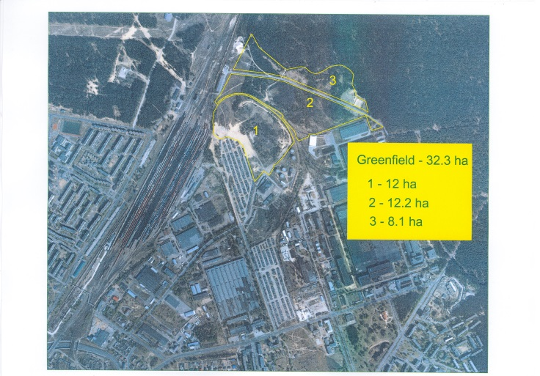

*Figure 18: Separate areas of the Northern industrial zones in Daugavpils*

Address of the industrial territory: industrial zone is located in the Northern part of Daugavpils, i.e., between Visku – Spalu – Slavu – Logistikas Streets, in the area of Visku - Mendelejeva streets.

Total area of the industrial territory: 117.4 ha, including

* **unutilised territory** (currently – green zone)**: 27 ha**

Zoning according to the planning of the district territory: industrial territory

## Property rights

In general majority of buildings and land plots in the Northern industrial zone is owned by 35 private owners, the largest owner of buildings and land is the LLC (SIA) “Saida”, where the establishment of Business Park is planned. Developer of the Business Park is an Iceland enterprise “Nordic Partner” with significant experience in operation of business parks also in the territory of Latvia, in Riga (Babite), Olaine and Jelgava.

Large areas of land and buildings are owned by the enterprises LLC (SIA) “Olimpiks”, LLC (SIA) “ST parks”, LLC (SIA) “Nexis FIbers”, and the enterprises are ready to rent or sell their areas of production.)

Owner of 27 ha land plot - Daugavpils City Council.

## Entrepreneurship sector

Commercial activity of several sectors. Recommended specialization: manufacture of equipment and transport, manufacture of textiles and clothing, production of foodstuffs

## General description and goals of the project

Goals of the investment zone development are –

1. Facilitation of establishment of new enterprises and investment attraction in the Northern industrial zone, Daugavpils,
2. Transformation of 27 ha (12 + 12 + 3 ha) unutilised land plot owned by the local government into industrial zone by situating there manufacture buildings and warehouses, thus establishing in the city a completely new manufacture centre,
3. Facilitation of favourable entrepreneurship environment formation and economic activity in the territory of Daugavpils city thus improving availability of infrastructure the largest industrial zone of Daugavpils.

## Description of the industrial zone

Total area 117.4 ha, including 611 000 m2 of utilised territory, additional 27 ha - unutilised built territory. 27 ha unutilised land plot owned by the local government.

A building constructed in the 80-ies of the last century (former spinning and weaving workshop) and currently owned by the LLC (SIA) “Olimpiks”, as well as three unutilised buildings owned by the LLC (SIA) “Nexis Fibers” are located in the industrial zone. Organizing of small production units, warehouse and office premises is possible in several buildings, part of them is owned by the municipal enterprise “Sadzīves pakalpojumu kombināts” [“Consumer services complex”]. Significant industrial objects of the city operate in the territory: the LLC (SIA) “Nexis Fibers”, the LLC (SIA) “Axon Cable”, the LLC (SIA) “Belmast”, the LLC (SIA) “Latgales ceļdaris” and other.

The largest building (16 ha) is owned by the Business Park “Nordic Partner Properties”. Upon situating manufacturing in the territory of the business park the services provided by the business park can be used.

29.1% of the buildings in the industrial buildings are loaded for the purposes of manufacture or provision of services. Significant industrial objects of the city with total annual turnover exceeding 39 million EUR (in 2013) operate in the territory.

Northern industrial zone (117 ha) is one of the largest industrial territories of Daugavpils, where several exporting enterprises successfully operate, and the territory has sufficient perspectives for attraction of new enterprises. Significant industrial objects of the city operate in the Northern industrial zone: LLC (SIA) “Zieglera mašīnbūve”, JSC (A/s) “Ditton pievadķēžu rūpnīca”, JSC (A/s) “Latvijas maiznieks”, LLC (SIA) “Magistr”, LLC (SIA) “Bio Nams”, LLC (SIA) “Merk Poligrāfs” and other, which is a positive precondition for the development of additional land plots and inclusion thereof in the active industrial territory.

Following up the ERDF project “Infrastructure development of the Northern industrial zone”, which was commenced in the planning period 2007 – 2013, Daugavpils city local government plans supporting of adjustment of the public territory infrastructure for the largest manufacturing and exporting enterprises (LLC (SIA) “Aurora Baltika”, LLC (SIA) “S.G. Avers”, LLC (SIA) “Axon Cable”, LLC (SIA) “Jordan polymers”, LLC (SIA) “Belmast”, LLC (SIA) “Nexis Fibers” and other enterprises) operating in the respective industrial zone, as well as for the potential new investors.

**Territory** currently complying with the status of unutilised building territory - **27 ha unutilised land plot,** which can be transformed into industrial zone situating industrial buildings and warehouses, thus creating in the city a brand new industrial centre.

Several independent projects can be implemented in the territory, since the territory has been divided into 3 land plots (12ha + 12ha + 3ha), separated by the railway line.

Infrastructure and availability of communications in the industrial territory:

|  |  |  |  |
| --- | --- | --- | --- |
| *Type* | | | *Distance* |
| Access road ⌧ Asphalt 🞎 Gravel 🞎 Earth surface | | | Access roads lead to the territory from three sides |
| Nearest roads | A6 (Riga – Daugavpils – Kraslava – Border of Belarus (Pāternieki))  A13 (Border of Russia (Grebneva) – Rezekne –Daugavpils – Border of Lithuania (Medumi))  P68 (Daugavpils – Skrudaliena – Border of Belarus (Silene) | | |
| Nearest ports | Riga, Klaipeda | | 227km, 402km |
| Nearest cities Rezekne | | | 90km |
| Railway ⌧ In the territory 🞎 Available 🞎 Non-  available | | | Territory is accessed by 2 railway lines, usable in the whole territory |
| International airports | Riga (LV), Vilnius (LT) | | 227km, 175km |
| General aviation aerodrome | | Daugavpils | 15km |
| Access to scientific personnel, advice | | Daugavpils, Rezekne | 0km, 90km |

Industrial enterprises with large consumption of power can be established in the Northern industrial zone, since high power and gas can be provided in the territory, and the third city heating plant is located next to it. The buildings have been constructed between 1958 and 1985. 16 unoccupied objects are on offer in the Northern industrial zone at the beginning of 2015.

|  |  |  |
| --- | --- | --- |
| *Capacity / Type* | | *Distance* |
| Electricity | Available, 50MV cable line | 0.0 km |
| Gas | Available, connection to high pressure natural gas pipes is possible | 0.0 km |
| Sewerage | Available, connection to city sewerage system is possible | 0.0 km |
| Water | Available, connection to city water supply system is possible | 0.0 km |
| Comments | If necessary, connection to district heating system of the city is possible | |

## Analysis of investor’s opportunities

The current transport infrastructure and the nearby border with Lithuania, Belarus and Russia makes the city attractive to freight transporters and offers entrepreneurship development opportunities if the field of transport and logistic services.

The most significant advantages of investors are indicated in page 14 of this document.

Besides, significant advantages to the investors will be provided after reconstruction of Daugavpils regional airport. The territory is located at the distance of 15 km from Daugavpils. Distance to the railway station – 2 km. Territory is located by the motorways A13 and A7. On the basis of technically economical justification developed in 2012 reconstruction of Daugavpils regional airport and certification thereof for regular air traffic would take at least 2 years.

Currently Daugavpils city is connected with other populated areas by roads and railroads. There is developed public transport in the city running both in the administrative territory of the city and in regional scale (to the centres of nearby parishes), and providing intercity and even cross-border passenger transportation. The planned construction of airport and establishment of air transport in the city will make it more available at national and international level.

The territory is reached by railway line, good connection with transit roads is provided, as well as water supply and gas – in the territory of the LLC (SIA) “Zieglera mašīnbūve” or the JSC (A/s) “Ditton pievadķēžu rūpnīca”. Part of the buildings in the zone is owned by the local government. There is also a wide area of land (currently unutilised) (6ha) with buildings owned by the JSC (A/s) “Latgale Invest holding”.

Natural persons and legal entities sell properties for situation of small production units, warehouses and office premises. Due to availability of the TEN-T network and national level motorways A6, A13, P67 and P68 the territory is connected with all main roads.

Local government of the city has undertaken to reconstruct roads and engineering communications with sufficient power, to support the development of territory and to facilitate increase of production capacity of the current and new entrepreneurs for the development of current manufacture and attraction of new leaseholders.

## List of potential clients and cooperation partners

* Daugavpils city local government
* Latgale Region Development Agency
* Regional business support organizations
* Investment and Development Agency of Latvia
* Private capital, including real estate developers
* Clients interested in construction of new objects
* Enterprises already working in the Northern industrial zone
* Providers of further education services
* State Employment Agency
* Daugavpils University
* Job seekers of Latgale region

## Summary of investments

Total amount of investments necessary for the implementation of the investment project depends on the entrepreneurship sector chosen by the investor and the specificity.

Local government will invest in small and large scale infrastructure within limits in order to create favourable conditions for the investors, as well as examine its opportunities to provide financial stimuli and solutions in the field of human resources to improve the current condition of industrial territories and support measures for investors.

So far Daugavpils city local government has partly reconstructed access roads and infrastructure to be continued in 2015. Inspection of territory of the Northern industrial zone has been performed, and topographical measurement has been developed for the development of technical design “Reconstruction of Mendeļejeva Street within the section between Višķu Street and Višķu Street 21D” – topographical plan (≈1.8 ha). The abovementioned measures are very significant for the further development of the whole Northern industrial zone, including 27 ha of green zone.

**Financial calculations carried out for the implementation of investment project:**

|  |  |
| --- | --- |
| **Measure** | **Indicative total sum (EUR),**  **incl. EU co-funding, if applicable** |
| Development of detailed planning | 38 000 – 42 000 |
| Development of technical documentation (technical design) for the provision of technical infrastructure of the territory | 15-20 EUR / sq.m |
| Construction of the public technical infrastructure of the Northern industrial zone – revitalization of the areas of degraded territories (approximately 6 ha) | 3 927 500 |
| Construction of simplified (hangar-type) industrial buildings | 300 - 450 EUR per m2 |
| Construction of new buildings (office premises, specific industrial buildings) | 500 - 670 EUR per m2 |
| Dismantling of the old buildings | See below  (Source: Latvian construction portal *abc.lv)* |
| Establishment of communications |
| Land works |
| Improvement works |
| Average wage NET (per month) | 350 – 450 EUR |

**Average** costs **for the establishment of communications** (2014)

|  |  |  |  |  |
| --- | --- | --- | --- | --- |
| [**Name of works and expenses**](http://www.abc.lv/?template=2013_abc_raksts&article=komunikaciju_ierikosana_2014&buvizmaksa_2009_komunikaciju_ierikosana_sort=0) | [**Unit**](http://www.abc.lv/?template=2013_abc_raksts&article=komunikaciju_ierikosana_2014&buvizmaksa_2009_komunikaciju_ierikosana_sort=1) | [**Wage per unit (EUR)**](http://www.abc.lv/?template=2013_abc_raksts&article=komunikaciju_ierikosana_2014&buvizmaksa_2009_komunikaciju_ierikosana_sort=2) | [**Material costs, EUR (from - to)**](http://www.abc.lv/?template=2013_abc_raksts&article=komunikaciju_ierikosana_2014&buvizmaksa_2009_komunikaciju_ierikosana_sort=3) | [**Mechanism costs, EUR**](http://www.abc.lv/?template=2013_abc_raksts&article=komunikaciju_ierikosana_2014&buvizmaksa_2009_komunikaciju_ierikosana_sort=4) |
| Electric installation works | m2 of the building | 6.00–11.40 | 12.80–28.50 | 1.00–5.00 |
| Heating (excluding the boiler system) | m2 of the building | 4.10–6.40 | 15.65–25.60 | 0.70–2.15 |
| Water supply | m2 of the building | 4.80–7.10 | 6.70–14.20 | 0.30–1.85 |
| Sewerage | m2 of the building | 5.70–8.50 | 8.55–21.35 | 0.45–2.15 |
| Ventilation | m2 of the building | 3.00–5.70 | 12.10–15.65 | 0.85–2.15 |
| Air condition | m2 of the building | 6.40–14.20 | 14.20–35.60 | 1.15–2.15 |
| Low intensity current | m2 of the building | 0.70–4.00 | 2.10–7.00 | 0.10–0.30 |
| Fire alarm | m2 of the building | 0.70–9.80 | 1.85–17.10 | 0.10–0.30 |
|  |  |  |  |  |

***Remarks:***  *1) Prices of resources may be clarified after detailed development of the design only, when all the construction conditions, volumes, validity provisions and complexity are coordinated  
2) Prices exclude employer’s and employee’s taxes   
3) Prices are determined according to the construction norms of Latvia and conditions of market situation  
4) Material costs exclude transport expenses and 21% VAT  
5) Prices are approximate – prices of separate services may differ from the prices indicated in the table depending on quality, speed and complications of the service provision   
6) Prices are more in line with industrial objects and large volume orders, since data have been obtained through analysis of the results of state and municipal procurements*

**Average** costs **of land works** (2014)

|  |  |  |  |  |
| --- | --- | --- | --- | --- |
| [**Name of works and expenses**](http://www.abc.lv/?template=2013_abc_raksts&article=komunikaciju_ierikosana_2014&buvizmaksa_2009_komunikaciju_ierikosana_sort=0) | [**Unit**](http://www.abc.lv/?template=2013_abc_raksts&article=komunikaciju_ierikosana_2014&buvizmaksa_2009_komunikaciju_ierikosana_sort=1) | [**Wage per unit (EUR)**](http://www.abc.lv/?template=2013_abc_raksts&article=komunikaciju_ierikosana_2014&buvizmaksa_2009_komunikaciju_ierikosana_sort=2) | [**Material costs, EUR (from - to)**](http://www.abc.lv/?template=2013_abc_raksts&article=komunikaciju_ierikosana_2014&buvizmaksa_2009_komunikaciju_ierikosana_sort=3) | [**Mechanism costs, EUR**](http://www.abc.lv/?template=2013_abc_raksts&article=komunikaciju_ierikosana_2014&buvizmaksa_2009_komunikaciju_ierikosana_sort=4) |
| Digging of foundation pit with excavator | 100 m3 | 12.10–14.20 |  | 120.95–142.30 |
| Digging of foundation pit with hands | m3 | 2.85–5.00 |  |  |
| Grading of the base of foundation pit | 100 m2 | 4.30 |  | 35.60–56.90 |
| Grading of the territory | 100 m2 | 4.30 |  | 35.60–56.90 |
| Removal of spare ground | 100 m3 | 12.10–14.20 |  | 120.95–142.30 |
| Digging of trenches for the communications with mechanisms | r.m | 0.20–0.40 |  | 1.20–2.30 |
| Digging of trenches with hands | m3 | 2.85–5.00 |  |  |
| Fixation of trenches with boards | m2 | 1.40–2.15 | 3.70–5.40 | 0.30 |
| Ground pouring with hands | 100 m3 | 2.85–5.00 |  |  |
| Ground pouring with mechanisms | 100 m3 | 12.10–14.20 |  | 120.95–142.30 |
|  |  |  |  |  |

Costs of **dismantling works** (2014)

|  |  |  |  |  |
| --- | --- | --- | --- | --- |
| [**Name of works and expenses**](http://www.abc.lv/?template=2013_abc_raksts&article=komunikaciju_ierikosana_2014&buvizmaksa_2009_komunikaciju_ierikosana_sort=0) | [**Unit**](http://www.abc.lv/?template=2013_abc_raksts&article=komunikaciju_ierikosana_2014&buvizmaksa_2009_komunikaciju_ierikosana_sort=1) | [**Wage per unit (EUR)**](http://www.abc.lv/?template=2013_abc_raksts&article=komunikaciju_ierikosana_2014&buvizmaksa_2009_komunikaciju_ierikosana_sort=2) | [**Material costs, EUR (from - to)**](http://www.abc.lv/?template=2013_abc_raksts&article=komunikaciju_ierikosana_2014&buvizmaksa_2009_komunikaciju_ierikosana_sort=3) | [**Mechanism costs, EUR**](http://www.abc.lv/?template=2013_abc_raksts&article=komunikaciju_ierikosana_2014&buvizmaksa_2009_komunikaciju_ierikosana_sort=4) |
|  |  |  |  |  |
| Dismantling of concrete foundations | m3 | 9.10–14.20 |  | 10.70–21.35 |
| Dismantling of block walls | m3 | 6.40–10.00 |  | 10.70–21.35 |
| Removal of debris | m3 |  | 7.80–11.95 |  |
| Removal of door blocks | m2 | 0.70–3.60 |  | 1.40 |
| Dismantling of reinforced concrete foundations | m3 | 9.10–21.30 |  | 10.70–21.35 |
| Dismantling of reinforced concrete covering | m3 | 5.40–51.20 |  | 16.80–96.80 |
| Stripping of the board cladding | m2 | 0.40–0.70 |  | 0.30 |
| Breaking of floor foundation | m3 | 22.80–45.50 | 7.10–21.35 |  |
| Dismantling of floor covering | m2 | 0.40–1.40 |  | 0.70 |
| Dismantling of roof board deck | m2 | 0.40–0.85 |  | 0.15 |
| Dismantling of plastered wooden covering | m2 | 2.85–6.40 |  | 1.60 |
| Dismantling of wooden frame coated on both sides with thermal insulation | m2 | 1.40–2.85 |  | 1.15 |
| Dismantling of wooden frame coated and plastered walls on both sides with thermal insulation | m2 | 1.40–2.85 |  | 1.15 |
| Dismantling of boulder foundations | m3 | 8.50–11.40 |  | 10.70–21.35 |
| Removal of window blocks with window sills | m2 | 0.70-7.10 |  | 1.40 |
| Dismantling of sheet surfacing | m2 | 0.40–0.70 |  | 0.15 |
| Stripping of the structural board cladding of the covering | m2 | 0.40–0.70 |  | 0.30 |
| Dismantling of roll material roof surfacing | m2 | 0.30–0.60 |  | 0.15 |
| Clearance of room from debris | m3 | 4.30–11.40 |  | 1.40 |
| Dismantling of gypsum plasterboard cladding on metal frame | m2 | 0.70–1.40 |  | 0.70 |
| Dismantling of gypsum plasterboard partition walls on metal frame | m2 | 1.15–2.15 |  | 0.85 |
| Dismantling of brick walls | m3 | 5.10–8.55 |  | 10.70–17.10 |

Costs of **improvement works** (2014)

|  |  |  |  |  |
| --- | --- | --- | --- | --- |
| [**Name of works and expenses**](http://www.abc.lv/?template=2013_abc_raksts&article=komunikaciju_ierikosana_2014&buvizmaksa_2009_komunikaciju_ierikosana_sort=0) | [**Unit**](http://www.abc.lv/?template=2013_abc_raksts&article=komunikaciju_ierikosana_2014&buvizmaksa_2009_komunikaciju_ierikosana_sort=1) | [**Wage per unit (EUR)**](http://www.abc.lv/?template=2013_abc_raksts&article=komunikaciju_ierikosana_2014&buvizmaksa_2009_komunikaciju_ierikosana_sort=2) | [**Material costs, EUR (from - to)**](http://www.abc.lv/?template=2013_abc_raksts&article=komunikaciju_ierikosana_2014&buvizmaksa_2009_komunikaciju_ierikosana_sort=3) | [**Mechanism costs, EUR**](http://www.abc.lv/?template=2013_abc_raksts&article=komunikaciju_ierikosana_2014&buvizmaksa_2009_komunikaciju_ierikosana_sort=4) |
| Metal bar gate | pc | 71.15–142.30 | 355.70–2134.30 | 42.70 |
| Metal bar fence | r.m | 14.20–21.35 | 49.80–213.40 | 2.15 |
| Metal screen gate | pc | 42.70–71.15 | 185.00–498.00 | 21.35 |
| Metal screen fence | r.m | 2.10–4.30 | 3.00–6.40 | 1.30 |
| Concrete poles with plinth elements | r.m | 11.40–21.35 | 19.90–39.80 | 1.70 |
| Asphalt surfacing 6 cm, foundation excluded | m2 | 2.15–2.85 | 5.00–7.10 | 3.60 |
| Pavement surfacing 60 mm, foundation excluded | m2 | 3.60–7.10 | 8.50–10.00 | 1.40 |
| Macadam surfacing 15 cm thick | m2 | 1.40–2.85 | 3.00–3.80 | 2.15 |
| Establishment of grass with a 10 cm layer of top soil | m2 | 1.40–2.15 | 2.30–2.85 | 0.70 |
| Spread of concrete tiles, foundation excluded | m2 | 5.70–11.40 | 11.40–17.10 | 0.70 |
|  |  |  |  |  |

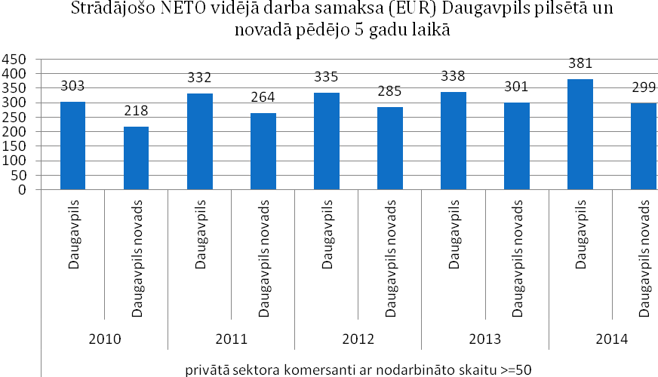

|  |  |
| --- | --- |
| Strādājošo NETO vidējā darba samaksa (EUR) Daugavpils pilsētā un novadā pēdējo 5 gadu laikā | Average NET wage (EUR) in Daugavpils city and Daugavpils district during the last 5 years |
| Daugavpils | Daugavpils |
| Daugavpils novads | Daugavpils district |
| Privātā sektora komersanti ar nodarbināto skaitu >=50 | Private sector merchants with >=50 employees |

*Figure 19:* Average NET wage in Daugavpils city and Daugavpils district

## Possible operational plan of the industrial territory in the future

|  |  |  |  |  |  |  |
| --- | --- | --- | --- | --- | --- | --- |
| **Zone/type of terri-tory** | **Offer of the local government** | | | | | **Administration** |
| **Lease of land** | **Sale of land** | **Buildings** | **Financial and tax stimuli** | **Non-financial bonuses from the local government** |
| Industrial park (focused on industrial sectors) | Long-term lease of land - maximum duration of the lease contract – 30 years (lease payment depends on improvements of the territory, between 900 and 1000 EUR/ha per year, including VAT) | Possible (price determined within evaluation of the land plot by certified evaluator shall be the entry price for auction of the land plot to be organized later and allowing participation of all interested persons) | Currently vacant territory (construction of buildings is up to the private investor) | Real estate tax relief up to 50% of the amount of tax (according to the binding regulations No. 25 “Regarding application of real estate tax relief in Daugavpils” issued by Daugavpils City Council) | Infrastructure projects – construction of roads and communications up to the object at the local government’s expense, participation in the city’s business development measures: catalogues, exhibitions, forums etc., informative support, assistance in search for specialists | Separate unit – territory leased from the local government, developed by private investor |

**Involved parties and their competencies**

|  |  |
| --- | --- |
| **Key involver parties** | **Competencies** |
| State | * Investments in infrastructure (main roads, Daugavpils airport, modernization of education institutions and other) * Financial stimuli (for example, reduction of labour force taxes) |
| Local government | * Provision of land, long-term lease to the private managers of the industrial territory * Real estate tax relief * Construction of public technical infrastructure – roads and communications – up to object * Notification of education institutions on necessity of specialized education and training programmes for the preparation of employees significant for the investors * Calling of education institutions to provide support for the enterprises in training of employees * Support in search for labour force and training of employees * Support in incubation of entrepreneurship * Inclusion of private investors in the city’s business development measures, including catalogues, exhibitions, forums (informative support) |
| Latgale planning region (Latgale Entrepreneurship Centre) | * Support for project management * Calling of the SEA (and other institutions in charge) to provide adult re-training and lifelong education programmes * Support in search for labour force and staff training * Support in search for business partners within the region for establishment of clusters (of specialized enterprises and other involved parties, including support institutions, groups with tight mutual cooperation within a certain territory and sector) * Support for enterprises in establishment of local supply chains * Provision of link with knowledge and technology transfer centres within the region (to be providing advice for development of new technologies and improvement of productivity) in order to increase technological competencies of the enterprises * Support in incubation of entrepreneurship, attraction of entrepreneurship grants and funding of funds |
| Private sector | * Construction of necessary buildings in the industrial zone * Management of the industrial territory and provision of services for other participants thereof * Establishment of electricity, IT infrastructure, water supply and sewerage networks, gas and heating inlets up to the objects * Recruitment * Corresponding adjustment of the industrial territory * Incubation of entrepreneurship, attraction of entrepreneurship grants and funding of funds |



|  |
| --- |
| **Liaison person of the local government:**  Daina Krīviņa, Head of the Development Department  Phone: 26422854; 65476060; e-mail – daina.krivina@daugavpils.lv |

## ANNEXES – other information related to the project

### Available technical documentation

Topographical measurement for the development of technical design “Reconstruction of Mendeļejeva street within the section between Višķu street and Višķu street 21D” – topographical measurement and development of topographical plan (≈1.8 ha) – which will promote adjustment (improvement) of the infrastructure of investment territory. Document of the topographical measurement is available as a separate volume of documents

### Presentation of description of the industrial zone (ppt)

Presentation (ppt) on Investment project for DAUGAVPILS Northern industrial zone in English and Russian

### Photographs of the industrial zone

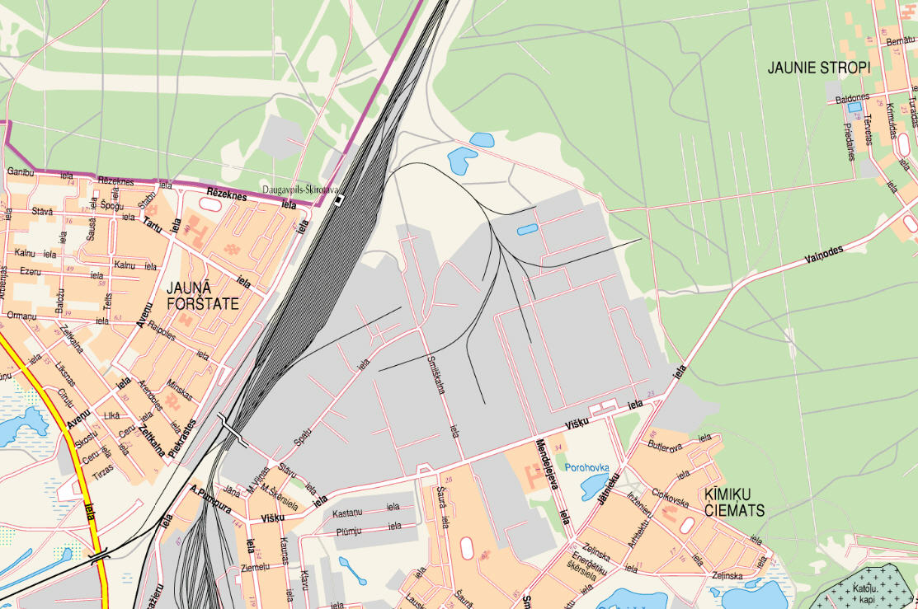

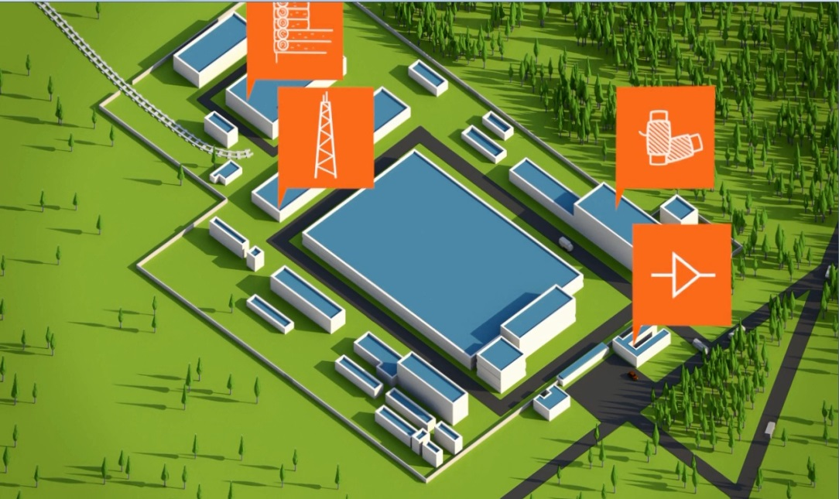

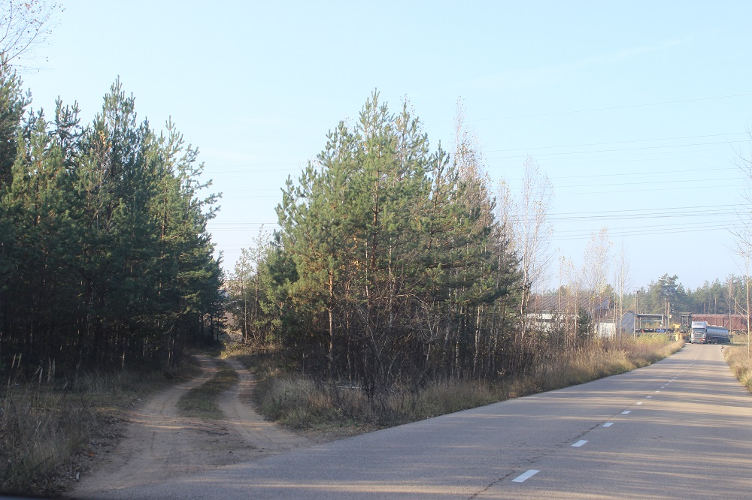

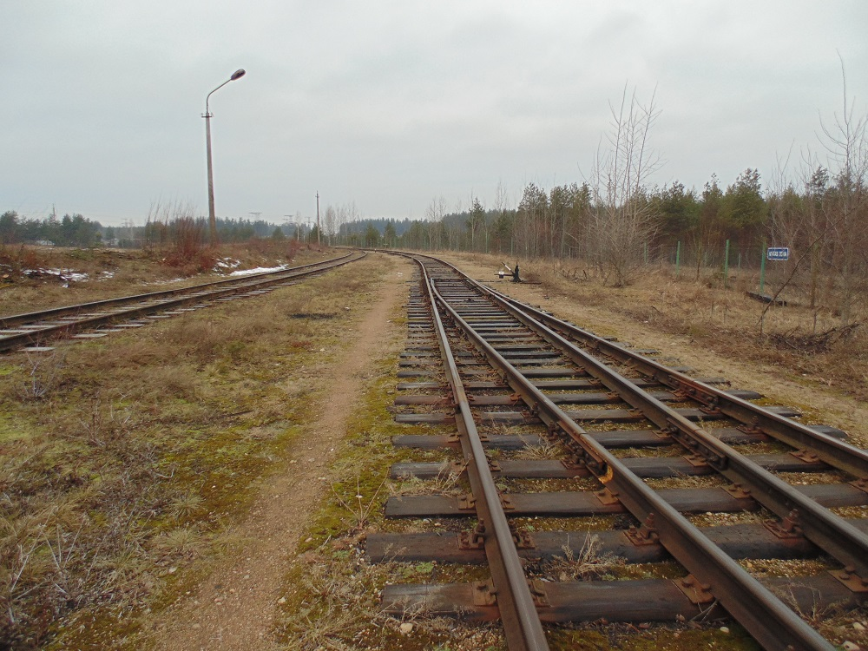

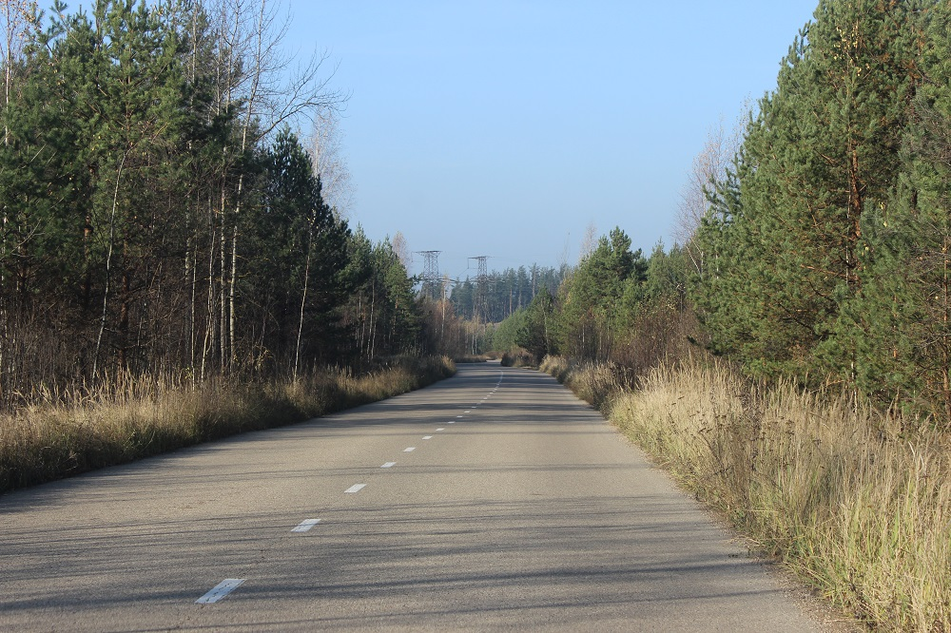

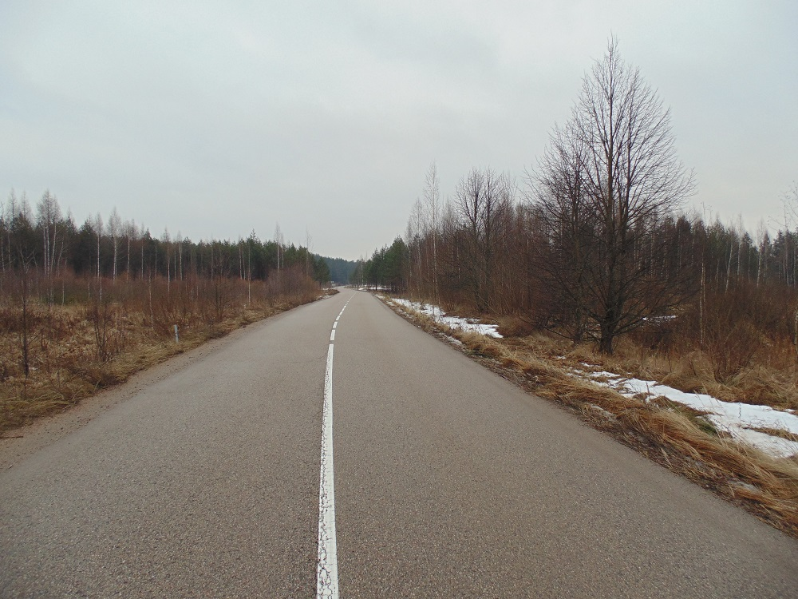

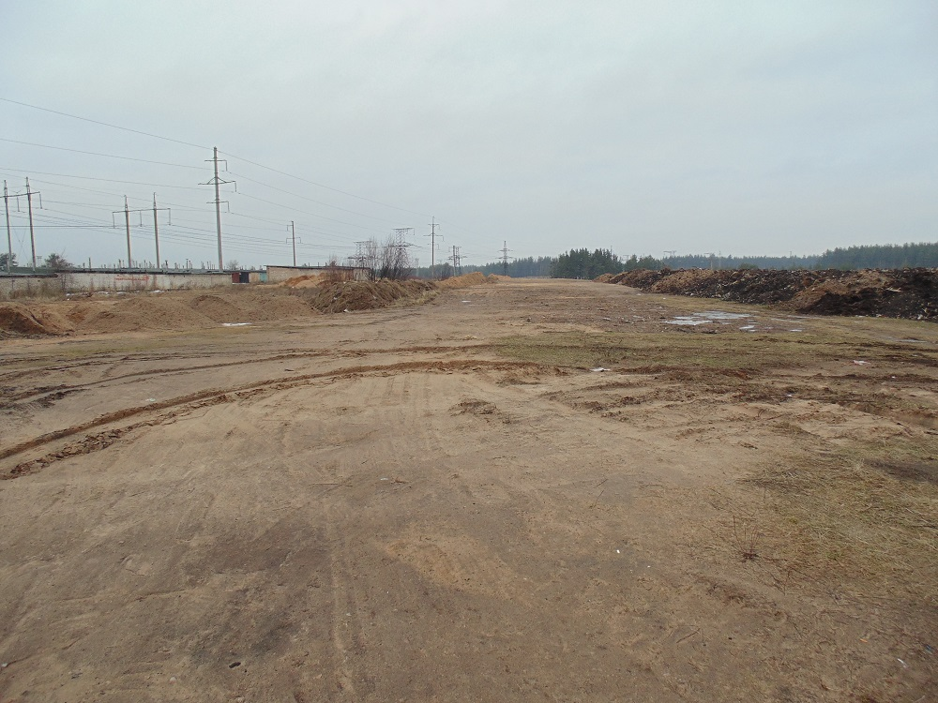

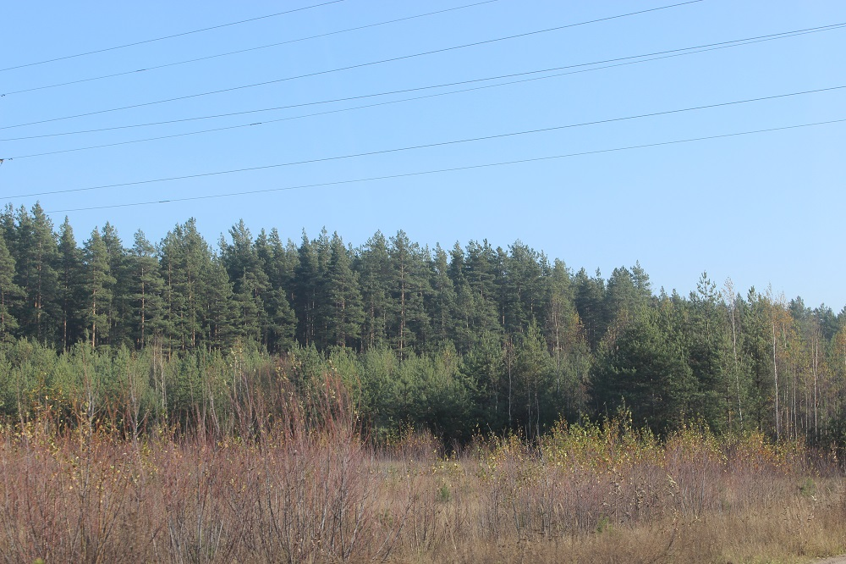

1. Legal entities and natural persons having manufactured products, provided services or employed people during the reference period in the corresponding period of time regardless of whether they were active for the entire reference period or part thereof.
2. Source: “Strategy for Investment Attraction to Urban Areas in LV-LT Cross-border Region” /2014/
3. Varied educational process of persons (aged between 25 and 64) providing person’s development and competitiveness in the labour market.
4. Selected on the basis of comparative advantages of Latgale – sectors including natural resources in Latgale (and Latvia), favourable geopolitical location, labour force skills and traditions in long-term period, competitiveness of educational and research institutions. Additional factor – speed of growth of the perspective sector worldwide, as well as the EU support for the solution of social challenges in separate sector (European Commission communication document “ES 2020”, managing initiative of the strategy “Innovation union”).
5. Packet of investment project within the context of WILLINVEST is an entirety of documents for a successful presentation of the urban territory owned by the local government to the potential investors. This will be the base for further work of the regional and local governments in investment attraction in the specific city territory (industrial zone), until these territories will be completely restored (document will serve at least 10 years after the end of the WILLINVEST project). Packet of investment project must stimulate active direct marketing of these zones (objects) both on the internet and on-the-spot in municipalities, and through the experts taking this information to business exhibitions and forums of investors. These results will stimulate further practice of investment projects and initiatives to satisfy needs of the local municipalities and provide higher economic and social welfare for the residents of Latgale region.